**Practical** **01**

# Step 1 : Install Android Studio

Android Studio provides a complete integrated development environment (IDE) including an advanced code editor and a set of app templates. In addition, it contains tools for development, debugging, testing, and performance that make it faster and easier to develop apps. You can test your apps with a large range of preconfigured emulators or on your own mobile device, build production apps, and publish on the Google Play store.

1. Navigate to the [Android developers site](https://developer.android.com/sdk/index.html) and follow the instructions to download and [install Android Studio.](https://developer.android.com/studio/install.html)
2. Accept the default configurations for all steps, and ensure that all components are selected for installation.
3. After finishing the install, the Setup Wizard will download and install some additional components including the Android SDK. Be patient, this might take some time depending on your Internet speed, and some of the steps may seem redundant.
4. When the download completes, Android Studio will start, and you are ready to create your first project.

# Step 2: Create the ‘Hello World’ app

In this task, you will create an app that displays "Hello World" to verify that Android studio is correctly installed, and to learn the basics of developing with Android Studio.

## 2.1 Create the app project

1. Open Android Studio if it is not already opened.
2. In the main Welcome to Android Studio window, click Start a new Android Studio project.
3. In the Create Android Project window, enter Hello World for the Application name.

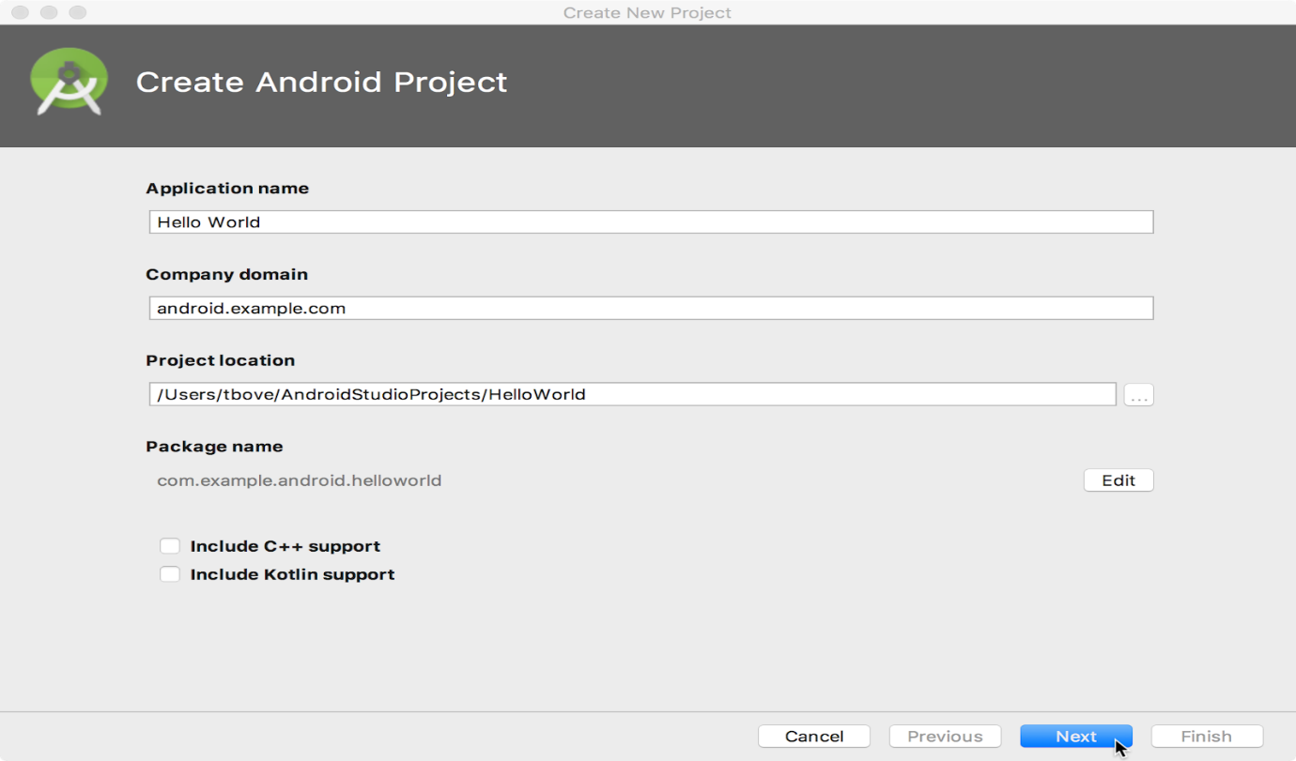

1. Verify that the default Project location is where you want to store your Hello World app and other Android Studio projects, or change it to your preferred directory.
2. Accept the default android.example.com for Company Domain, or create a unique company domain.

If you are not planning to publish your app, you can accept the default. Be aware that changing the package name of your app later is extra work.

1. Leave unchecked the options to Include C++ support and Include Kotlin support, and click Next.
2. On the Target Android Devices screen, Phone and Tablet should be selected. Ensure that API 15: Android 4.0.3 IceCreamSandwich is set as the Minimum SDK; if it is not, use the popup menu to set it.

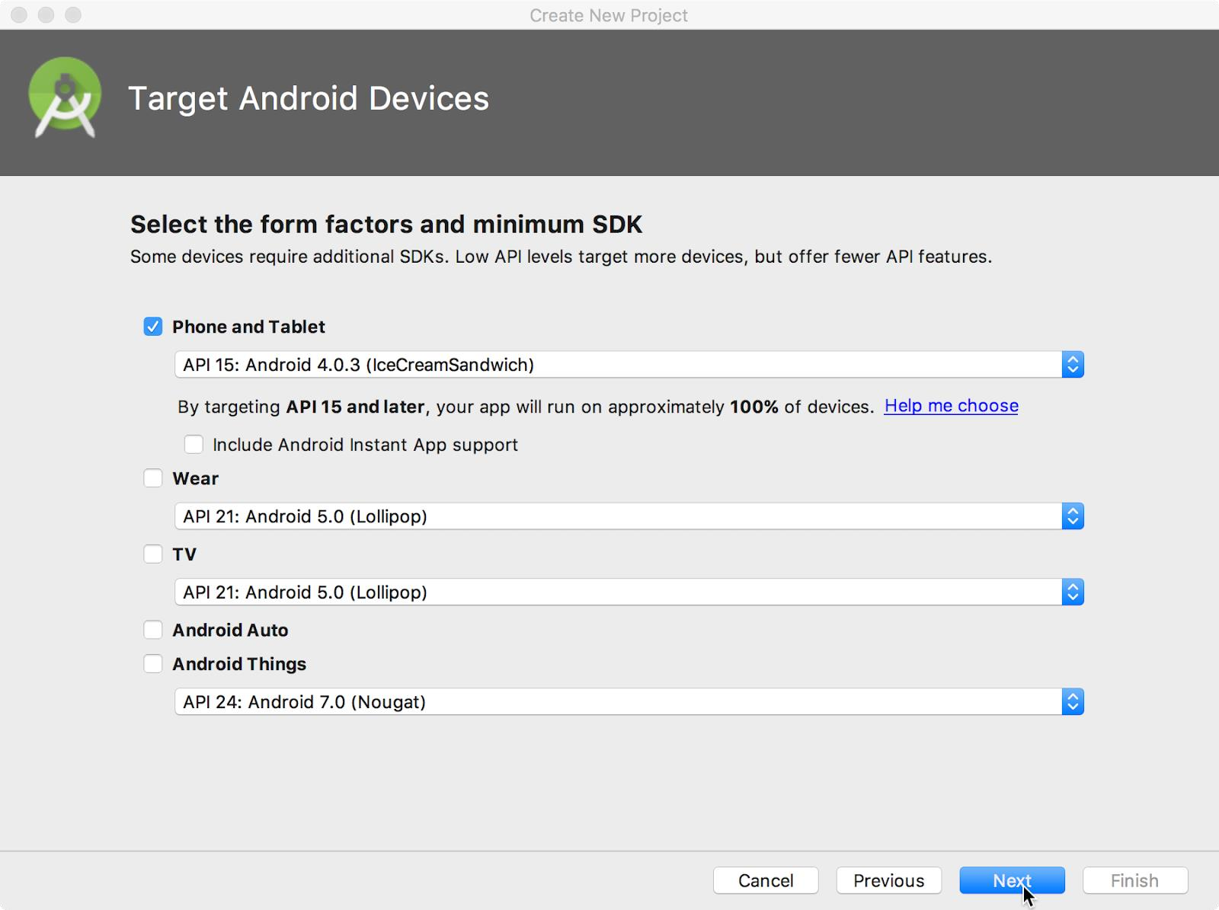

These are the settings used by the examples in the lessons for this course. As of this writing, these settings make your Hello World app compatible with 97% of Android devices active on the Google Play Store.

1. Leave unchecked the Include Instant App support and all other options. Then click Next. If your project requires additional components for your chosen target SDK, Android Studio will install them automatically.
2. The Add an Activity window appears. An [Activity](https://developer.android.com/reference/android/app/Activity.html) is a single, focused thing that the user can do. It is a crucial component of any Android app. An Activity typically has a layout associated with it that defines how UI elements appear on a screen. Android Studio provides Activity templates to help you get started. For the Hello World project, choose Empty Activity as shown below, and click Next.

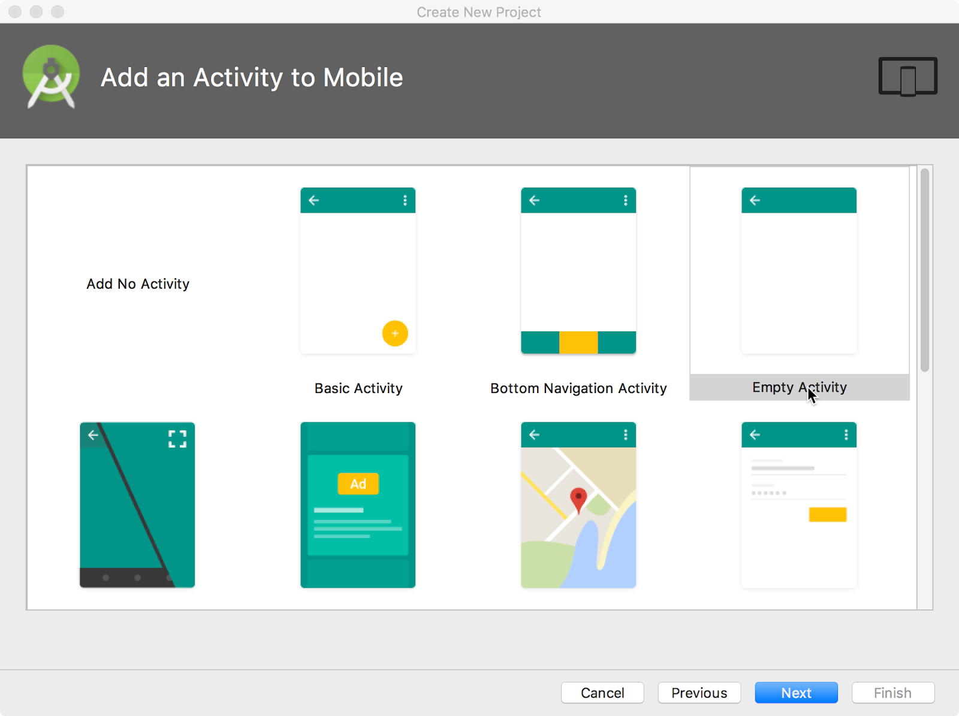

1. The Configure Activity screen appears (which differs depending on which template you chose in the previous step). By default, the empty Activity provided by the template uses MainActivity.

is named

MainA

ctivit

y

. You can change this if you want, but this lesson

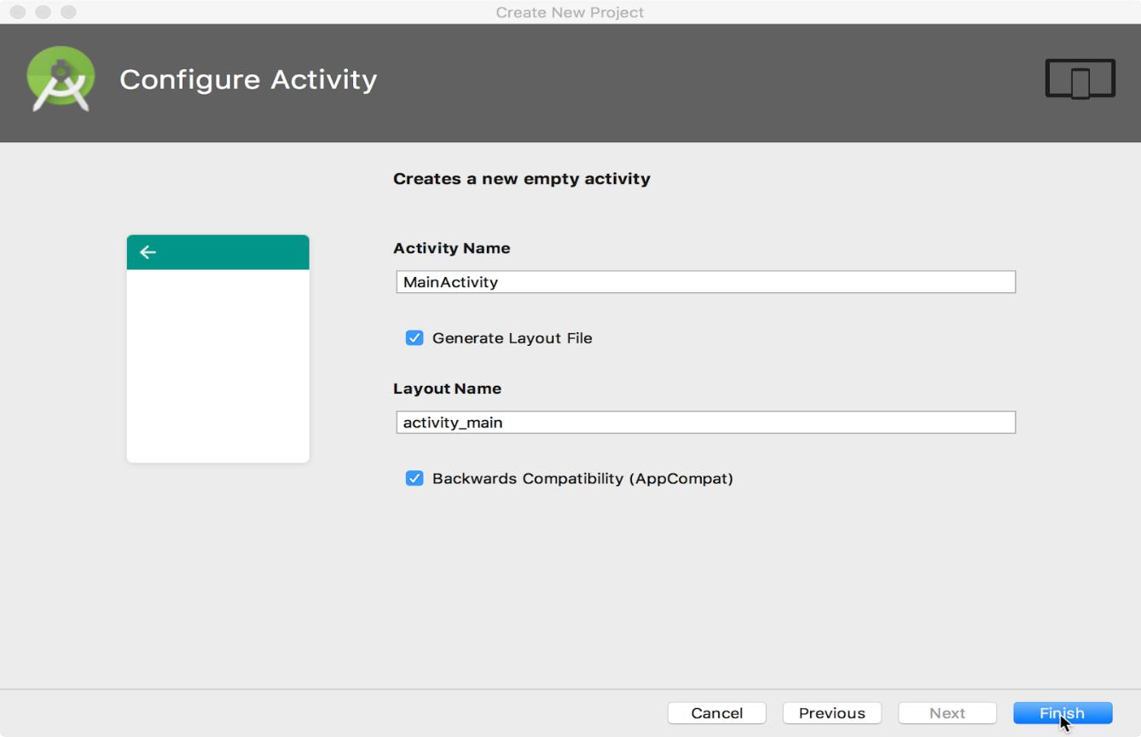

1. Make sure that the Generate Layout file option is checked. The layout name by default is activity_main. You can change this if you want, but this lesson uses activity_main.
2. Make sure that the Backwards Compatibility (App Compat) option is checked. This ensures that your app will be backwards-compatible with previous versions of Android.
3. Click Finish.

Android Studio creates a folder for your projects, and builds the project with [Gradle](https://gradle.org/) (this may take a few moments).

Tip: See the [Configure your build](https://developer.android.com/studio/build/index.html) developer page for detailed information.

You may also see a "Tip of the day" message with keyboard shortcuts and other useful tips. Click Close to close the message.

The Android Studio editor appears. Follow these steps:

1. Click the activity_main.xml tab to see the layout editor.
2. Click the layout editor Design tab, if not already selected, to show a graphical rendition of the layout as shown below.

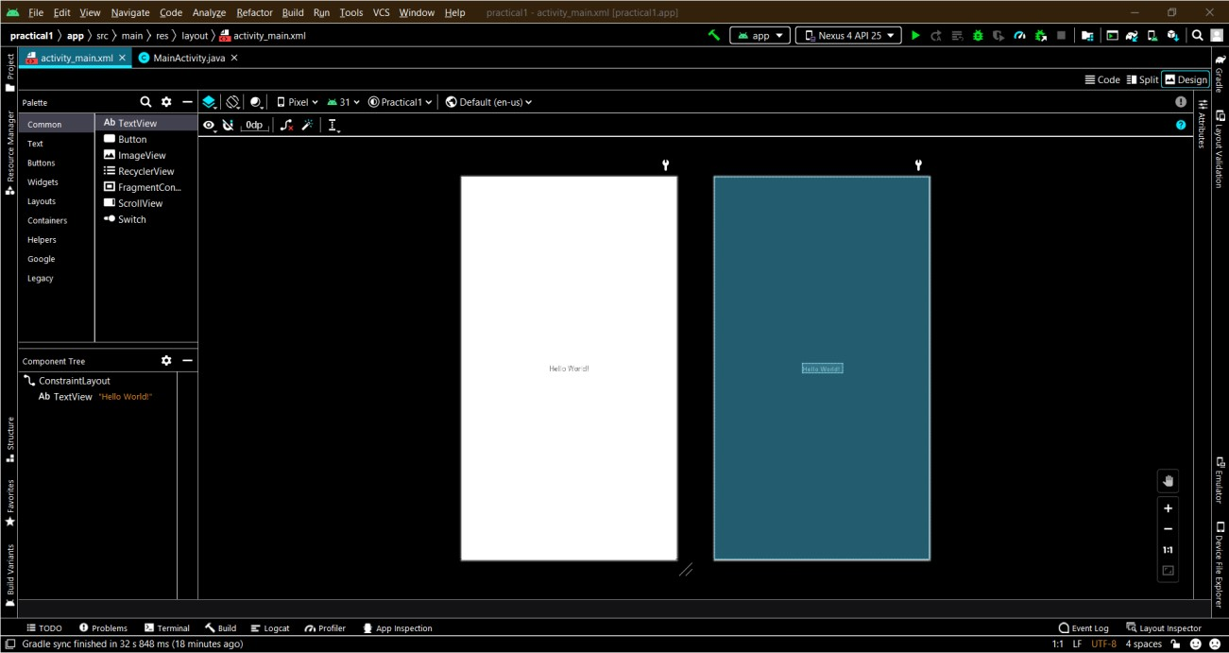

1. Click the MainActivity.java tab to see the code editor as shown below.

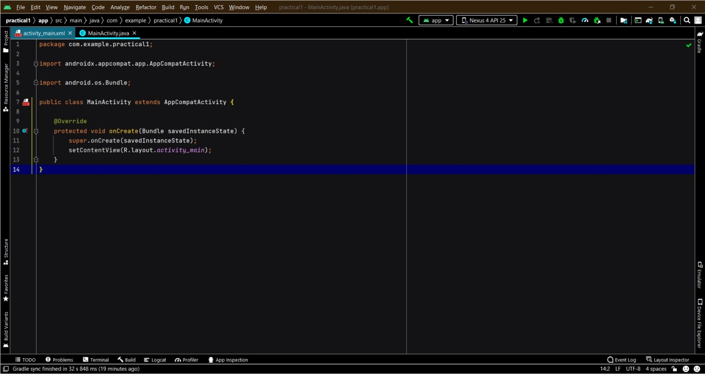

## 2.2 Explore the Project > Android pane

In this practical, you will explore how the project is organized in Android Studio.

1. If not already selected, click the Project tab in the vertical tab column on the left side of the Android Studio window. The Project pane appears.
2. To view the project in the standard Android project hierarchy, choose Android from the popup menu at the top of the Project pane, as shown below.

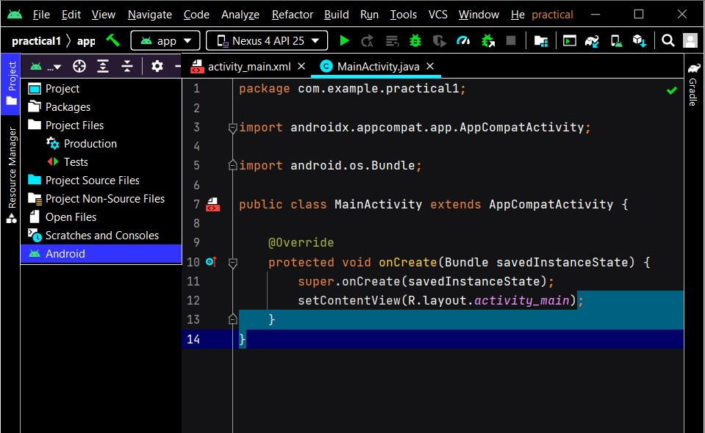

Note: This chapter and other chapters refer to the Project pane, when set to Android, as the Project > Android pane.

## 2.3 Explore the Gradle Scripts folder

The Gradle build system in Android Studio makes it easy to include external binaries or other library modules to your build as dependencies.

When you first create an app project, the Project > Android pane appears with the Gradle

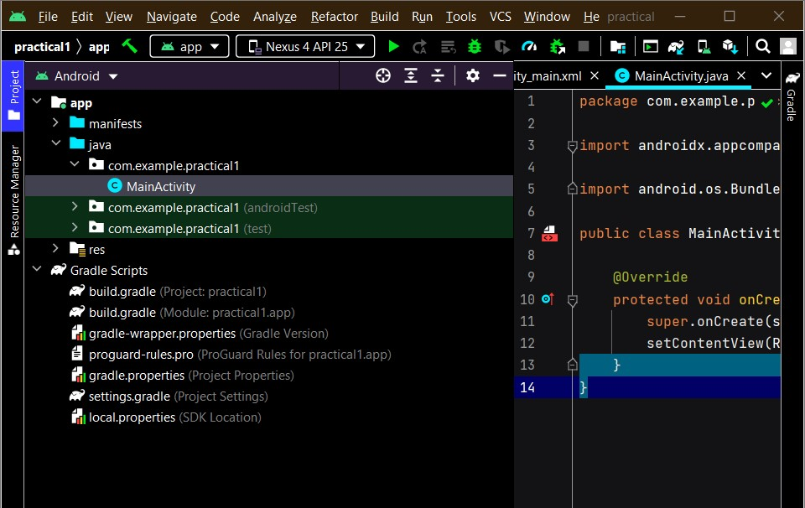

Scripts folder expanded as shown below.

Follow these steps to explore the Gradle system:

1. If the Gradle Scripts folder is not expanded, click the triangle to expand it.

This folder contains all the files needed by the build system.

1. Look for the build.gradle(Project: HelloWorld) file.

This is where you'll find the configuration options that are common to all of the modules that make up your project. Every Android Studio project contains a single, top-level Gradle build file. Most of the time, you won't need to make any changes to this file, but it's still useful to understand its contents.

By default, the top-level build file uses the buildscript block to define the Gradle repositories and dependencies that are common to all modules in the project. When your dependency is something other than a local library or file tree, Gradle looks for the files in whichever online repositories are specified in the repositories block of this file. By default, new Android Studio projects declare JCenter and Google (which includes the [Google Maven repository)](https://maven.google.com/) as the repository locations:

allprojects { repositories { google() jcenter()

}

}

3. Look for the build.gradle(Module:app) file.

In addition to the project-level build.gradle file, each module has a build.gradle file of its own, which allows you to configure build settings for each specific module (the HelloWorld app has only one module). Configuring these build settings allows you to provide custom packaging options, such as additional build types and product flavors. You can also override settings in the AndroidManifest.xml file or the top-level build.gradle file.

This file is most often the file to edit when changing app-level configurations, such as declaring dependencies in the dependencies section. You can declare a library dependency using one of several different dependency configurations. Each dependency configuration provides Gradle different instructions about how to use the library. For example, the statement implementation fileTree(dir: 'libs', include: ['*.jar']) adds a dependency of all ".jar" files inside the libs directory.

The following is the build.gradle(Module:app) file for the HelloWorld app:

apply plugin: 'com.android.application'

android { compileSdkVersion 26 defaultConfig {

applicationId "com.example.android.helloworld" minSdkVersion 15 targetSdkVersion 26 versionCode 1 versionName "1.0" testInstrumentationRunner

"android.support.test.runner.AndroidJUnitRunner"

}

buildTypes { release { minifyEnabled false proguardFiles

getDefaultProguardFile('proguard-android.txt'), 'proguard-rules.pro'

}

}

}

dependencies {

implementation fileTree(dir: 'libs', include: ['*.jar']) implementation 'com.android.support:appcompat-v7:26.1.0' implementation

'com.android.support.constraint:constraint-layout:1.0.2' testImplementation 'junit:junit:4.12'

androidTestImplementation 'com.android.support.test:runner:1.0.1' androidTestImplementation

'com.android.support.test.espresso:espresso-core:3.0.1' }

4. Click the triangle to close Gradle Scripts.

## 2.4 Explore the app and res folders

All code and resources for the app are located within the app and res folders.

1. Expand the app folder, the java folder, and the com.example.android.helloworld folder to see the Main Activity java file. Double-clicking the file opens it in the code editor.

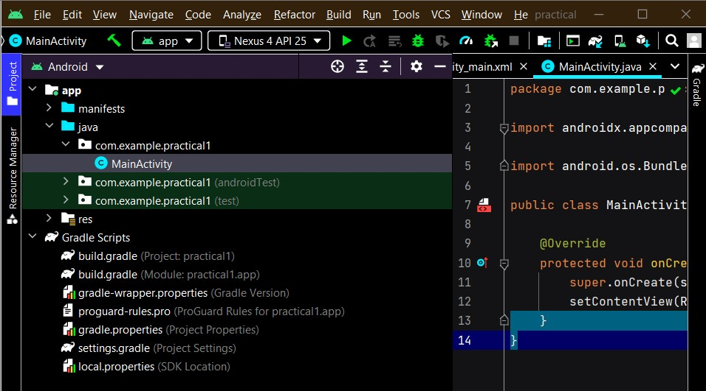

The java folder includes Java class files in three subfolders, as shown in the figure above. The com.example.hello.helloworld (or the domain name you have specified) folder contains all the files for an app package. The other two folders are used for testing and described in another lesson. For the Hello World app, there is only one package and it contains MainActivity.java. The name of the first Activity (screen) the user sees, which also initializes app-wide resources, is customarily called MainActivity (the file extension is omitted in the Project > Android pane).

1. Expand the res folder and the layout folder, and double-click the activity_main.xml file to open it in the layout editor.

The

res

folder holds resources, such as layouts, strings, and images. An

Activit

y

is usually

as

sociated

with a layout of UI views defined as an XML file. This

file is usually named after

its

Activit

y

.

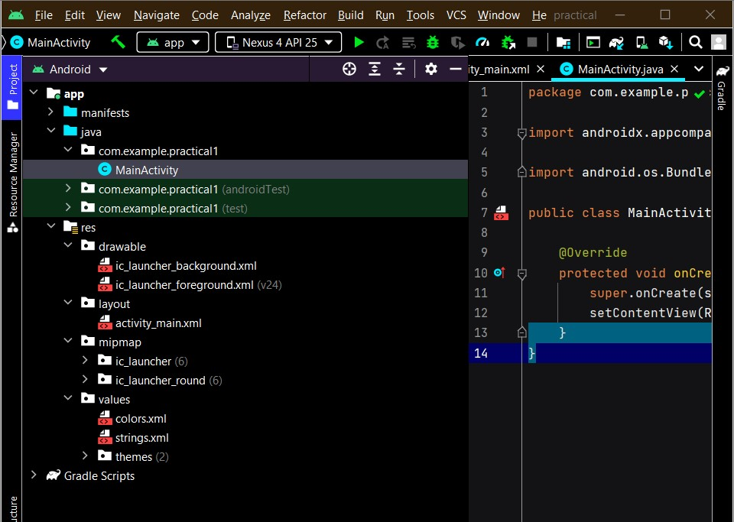

|  |  |
| --- | --- |
| Swarangi Gawde Android Developer Fundamentals | SY BSc CS |
| Div: A (TCSCCS0407P) | Roll No. : 4343 |
| **Practical 2 Source Code:**  **Activity_main.xml**  <?xml version="1.0" encoding="utf-8"?>  <LinearLayout xmlns:android="http://schemas.android.com/apk/res/android" xmlns:app="http://schemas.android.com/apk/res-auto" xmlns:tools="http://schemas.android.com/tools" android:layout_width="match_parent" android:layout_height="match_parent" tools:context=".MainActivity" android:background="#2C3E50" android:orientation="vertical">  <LinearLayout android:layout_width="match_parent" android:layout_height="wrap_content" android:layout_weight="0.3" android:orientation="horizontal">  <TextView android:id="@+id/display" android:layout_width="match_parent" android:layout_height="match_parent" android:background="#262626" android:textColor="@color/white" android:textSize="30sp" />  </LinearLayout>    <LinearLayout  android:layout_width="match_parent" android:layout_height="wrap_content" android:layout_weight="0.2" android:orientation="horizontal"> <Button | 11 |

|  |  |
| --- | --- |
| Swarangi Gawde Android Developer Fundamentals | SY BSc CS |
| Div: A (TCSCCS0407P) | Roll No. : 4343 |
| android:id="@+id/clear" android:layout_width="wrap_content" android:layout_height="match_parent" android:layout_margin="1dp" android:layout_weight="0.25" android:text="Clear" android:textColor="#ecf0f1" android:textSize="20sp" />  <Button android:id="@+id/equal" android:layout_width="wrap_content" android:layout_height="match_parent" android:layout_margin="1dp" android:layout_weight="0.25" android:text="=" android:textColor="#ecf0f1" android:textSize="30sp" />  </LinearLayout> <LinearLayout android:layout_width="match_parent" android:layout_height="wrap_content" android:layout_weight="0.2" android:orientation="horizontal">  <Button android:id="@+id/one"  android:layout_width="wrap_content" android:layout_height="match_parent" android:layout_margin="1dp" android:layout_weight="0.25" android:text="1"  android:textColor="#ecf0f1" android:textSize="20sp" /> | 12 |

|  |  |  |
| --- | --- | --- |
| Swarangi Gawde Android Developer Fundamentals | | SY BSc CS |
| Div: A | (TCSCCS0407P) | Roll No. : 4343 |
| <Button android:id="@+id/two" android:layout_width="wrap_content" android:layout_height="match_parent" android:layout_margin="1dp" android:layout_weight="0.25" android:text="2" android:textColor="#ecf0f1" android:textSize="20sp" />  <Button android:id="@+id/three" android:layout_width="wrap_content" android:layout_height="match_parent" android:layout_margin="1dp" android:layout_weight="0.25" android:text="3" android:textColor="#ecf0f1" android:textSize="20sp" />  <Button android:id="@+id/division"  android:layout_width="wrap_content" android:layout_height="match_parent" android:layout_margin="1dp" android:layout_weight="0.25" android:text="/"  android:textColor="#ecf0f1" android:textSize="30sp" />  </LinearLayout> <LinearLayout android:layout_width="match_parent" android:layout_height="wrap_content" android:layout_weight="0.2" | | 13 |

|  |  |
| --- | --- |
| Swarangi Gawde Android Developer Fundamentals | SY BSc CS |
| Div: A (TCSCCS0407P) | Roll No. : 4343 |
| android:orientation="horizontal">  <Button android:id="@+id/four" android:layout_width="wrap_content" android:layout_height="match_parent" android:layout_margin="1dp" android:layout_weight="0.25" android:text="4" android:textColor="#ecf0f1" android:textSize="20sp" />  <Button android:id="@+id/five" android:layout_width="wrap_content" android:layout_height="match_parent" android:layout_margin="1dp" android:layout_weight="0.25" android:text="5" android:textColor="#ecf0f1" android:textSize="20sp" />  <Button  android:id="@+id/six"  android:layout_width="wrap_content" android:layout_height="match_parent" android:layout_margin="1dp" android:layout_weight="0.25" android:text="6"  android:textColor="#ecf0f1" android:textSize="20sp" />  <Button android:id="@+id/subtraction" android:layout_width="wrap_content" android:layout_height="match_parent" | 14 |

|  |  |
| --- | --- |
| Swarangi Gawde Android Developer Fundamentals | SY BSc CS |
| Div: A (TCSCCS0407P) | Roll No. : 4343 |
| android:layout_margin="1dp" android:layout_weight="0.25" android:text="-" android:textColor="#ecf0f1" android:textSize="30sp" />  </LinearLayout>    <LinearLayout android:layout_width="match_parent" android:layout_height="wrap_content" android:layout_weight="0.2" android:orientation="horizontal">  <Button android:id="@+id/seven" android:layout_width="wrap_content" android:layout_height="match_parent" android:layout_margin="1dp" android:layout_weight="0.25" android:text="7" android:textColor="#ecf0f1" android:textSize="20sp" />  <Button android:id="@+id/eight" android:layout_width="wrap_content" android:layout_height="match_parent" android:layout_margin="1dp" android:layout_weight="0.25" android:text="8"  android:textColor="#ecf0f1" android:textSize="20sp" />  <Button  android:id="@+id/nine" | 15 |

|  |  |
| --- | --- |
| Swarangi Gawde Android Developer Fundamentals | SY BSc CS |
| Div: A (TCSCCS0407P) | Roll No. : 4343 |
| android:layout_width="wrap_content" android:layout_height="match_parent" android:layout_margin="1dp" android:layout_weight="0.25" android:text="9" android:textColor="#ecf0f1" android:textSize="20sp" />  <Button android:id="@+id/multiplication" android:layout_width="wrap_content" android:layout_height="match_parent" android:layout_margin="1dp" android:layout_weight="0.25" android:text="x" android:textColor="#ecf0f1" android:textSize="30sp" />  </LinearLayout>    <LinearLayout android:layout_width="match_parent" android:layout_height="wrap_content" android:layout_weight="0.2" android:orientation="horizontal">  <Button android:id="@+id/decimal"  android:layout_width="wrap_content" android:layout_height="match_parent" android:layout_margin="1dp" android:layout_weight="0.25" android:text="."  android:textColor="#ecf0f1" android:textSize="20sp" /> | 16 |

|  |  |  |
| --- | --- | --- |
| Swarangi Gawde Android Developer Fundamentals | | SY BSc CS |
| Div: A | (TCSCCS0407P) | Roll No. : 4343 |
| <Button android:id="@+id/zero" android:layout_width="wrap_content" android:layout_height="match_parent" android:layout_margin="1dp" android:layout_weight="0.25" android:text="0" android:textColor="#ecf0f1" android:textSize="20sp" />  <Button android:id="@+id/Remainder" android:layout_width="wrap_content" android:layout_height="match_parent" android:layout_margin="1dp" android:layout_weight="0.25" android:text="%" android:textColor="#ecf0f1" android:textSize="30sp" />  <Button android:id="@+id/addition" android:layout_width="wrap_content" android:layout_height="match_parent" android:layout_margin="1dp" android:layout_weight="0.25" android:text="+"  android:textColor="#ecf0f1" android:textSize="30sp" />  </LinearLayout>  </LinearLayout> | | 17 |

Swarangi Gawde

Android Developer Fundamentals

SY BSc CS

Div: A

(

TCSCCS0407P

)

Roll No. : 4343

18

**Design:**

**MainActivity.java**

package com.example.practical1;

import androidx.appcompat.app.AppCompatActivity;

import android.view.View;

import

android.widget.Button;

import android.widget.TextView;

import android.os.Bundle;

public class MainActivity extends AppCompatActivity {

double input1 = 0, input2 = 0;

TextView edt1;

boolean Addition, Subtract, Multiplication, Division, mRemaind

er, decimal;

Button button0, button1, button2, button3, button4, button5, button6, button7, button8,

button9, buttonAdd, buttonSub,

buttonMul, buttonDivision, buttonEqual, buttonDel, buttonDot, Remainder;

@Override

protected void on

Create(Bundle savedInstanceState) {

super.onCreate(savedInstanceState);

setContentView(R.layout.activity_main);

button0 = (Button) findViewById(R.id.zero);

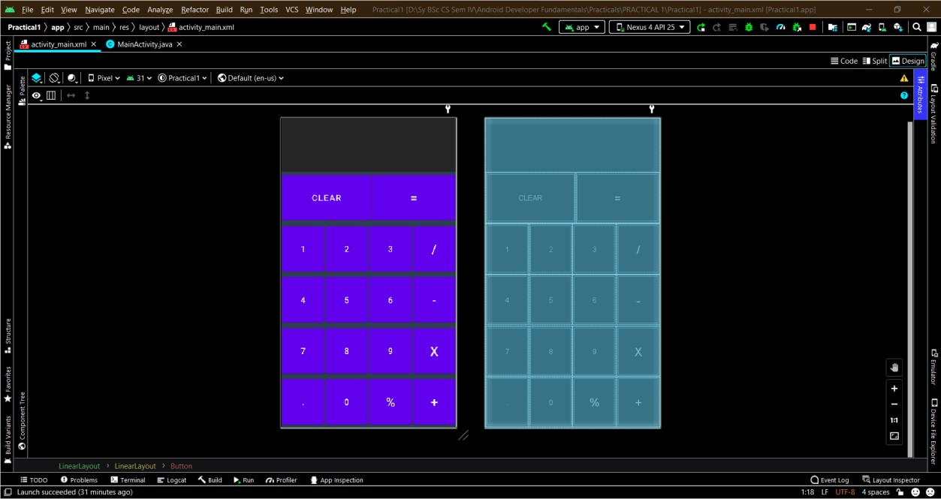

|  |  |
| --- | --- |
| Swarangi Gawde Android Developer Fundamentals | SY BSc CS |
| Div: A (TCSCCS0407P) | Roll No. : 4343 |
| button1 = (Button) findViewById(R.id.one); button2 = (Button) findViewById(R.id.two); button3 = (Button) findViewById(R.id.three); button4 = (Button) findViewById(R.id.four); button5 = (Button) findViewById(R.id.five); button6 = (Button) findViewById(R.id.six); button7 = (Button) findViewById(R.id.seven); button8 = (Button) findViewById(R.id.eight); button9 = (Button) findViewById(R.id.nine); buttonDot = (Button) findViewById(R.id.decimal); buttonAdd = (Button) findViewById(R.id.addition); buttonSub = (Button) findViewById(R.id.subtraction); buttonMul = (Button) findViewById(R.id.multiplication); buttonDivision = (Button) findViewById(R.id.division); Remainder = (Button) findViewById(R.id.Remainder); buttonDel = (Button) findViewById(R.id.clear); buttonEqual = (Button) findViewById(R.id.equal); edt1 = (TextView) findViewById(R.id.display); button1.setOnClickListener(new View.OnClickListener() {  @Override  public void onClick(View v) { edt1.setText(edt1.getText() + "1");  }  });  button2.setOnClickListener(new View.OnClickListener() {  @Override  public void onClick(View v) { edt1.setText(edt1.getText() + "2");  }  });  button3.setOnClickListener(new View.OnClickListener() { @Override | 19 |

|  |  |
| --- | --- |
| Swarangi Gawde Android Developer Fundamentals | SY BSc CS |
| Div: A (TCSCCS0407P) | Roll No. : 4343 |
| public void onClick(View v) { edt1.setText(edt1.getText() + "3");  }  });  button4.setOnClickListener(new View.OnClickListener() {  @Override public void onClick(View v) { edt1.setText(edt1.getText() + "4");  }  });  button5.setOnClickListener(new View.OnClickListener() {  @Override public void onClick(View v) { edt1.setText(edt1.getText() + "5");  }  });  button6.setOnClickListener(new View.OnClickListener() {  @Override public void onClick(View v) { edt1.setText(edt1.getText() + "6");  }  });  button7.setOnClickListener(new View.OnClickListener() {  @Override public void onClick(View v) { edt1.setText(edt1.getText() + "7");  }  });  button8.setOnClickListener(new View.OnClickListener() {  @Override  public void onClick(View v) { edt1.setText(edt1.getText() + "8"); | 20 |

|  |  |
| --- | --- |
| Swarangi Gawde Android Developer Fundamentals | SY BSc CS |
| Div: A (TCSCCS0407P) | Roll No. : 4343 |
| }  });  button9.setOnClickListener(new View.OnClickListener() {  @Override public void onClick(View v) { edt1.setText(edt1.getText() + "9");  }  });  button0.setOnClickListener(new View.OnClickListener() {  @Override public void onClick(View v) { edt1.setText(edt1.getText() + "0");  }  });  buttonAdd.setOnClickListener(new View.OnClickListener() {  @Override public void onClick(View v) { if (edt1.getText().length() != 0) {  input1 = Float.parseFloat(edt1.getText() + ""); Addition = true; decimal = false; edt1.setText(null);  }  }  });  buttonSub.setOnClickListener(new View.OnClickListener() {  @Override  public void onClick(View v) { if (edt1.getText().length() != 0) {  input1 = Float.parseFloat(edt1.getText() + ""); Subtract = true; decimal = false; | 21 |

|  |  |
| --- | --- |
| Swarangi Gawde Android Developer Fundamentals | SY BSc CS |
| Div: A (TCSCCS0407P) | Roll No. : 4343 |
| edt1.setText(null);  }  }  });  buttonMul.setOnClickListener(new View.OnClickListener() {  @Override public void onClick(View v) { if (edt1.getText().length() != 0) {  input1 = Float.parseFloat(edt1.getText() + ""); Multiplication = true; decimal = false; edt1.setText(null);  }  }  });  buttonDivision.setOnClickListener(new View.OnClickListener() {  @Override public void onClick(View v) { if (edt1.getText().length() != 0) {  input1 = Float.parseFloat(edt1.getText() + ""); Division = true; decimal = false; edt1.setText(null);  }  }  });  Remainder.setOnClickListener(new View.OnClickListener() {  @Override  public void onClick(View v) { if (edt1.getText().length() != 0) {  input1 = Float.parseFloat(edt1.getText() + ""); mRemainder = true; | 22 |

|  |  |
| --- | --- |
| Swarangi Gawde Android Developer Fundamentals | SY BSc CS |
| Div: A (TCSCCS0407P) | Roll No. : 4343 |
| decimal = false; edt1.setText(null);  }  }  });  buttonEqual.setOnClickListener(new View.OnClickListener() {  @Override public void onClick(View v) { if (Addition || Subtract || Multiplication || Division || mRemainder) { input2 = Float.parseFloat(edt1.getText() + "");  }  if (Addition) {  edt1.setText(input1 + input2 + "");  Addition = false;  } if (Subtract) {  edt1.setText(input1 - input2 + "");  Subtract = false;  }  if (Multiplication) {  edt1.setText(input1 * input2 + "");  Multiplication = false;  } if (Division) {  edt1.setText(input1 / input2 + "");  Division = false;  }  if (mRemainder) { edt1.setText(input1 % input2 + ""); mRemainder = false;  } | 23 |

|  |  |
| --- | --- |
| Swarangi Gawde Android Developer Fundamentals | SY BSc CS |
| Div: A (TCSCCS0407P) | Roll No. : 4343 |
| }  });  buttonDel.setOnClickListener(new View.OnClickListener() {  @Override public void onClick(View v) { edt1.setText(""); input1 = 0.0; input2 = 0.0;  }  });  buttonDot.setOnClickListener(new View.OnClickListener() {  @Override public void onClick(View v) { if (decimal) {  //do nothing or you can show the error  } else { edt1.setText(edt1.getText() + "."); decimal = true;  }  }  });  }  } | 24 |

Swarangi Gawde

Android Developer Fundamentals

SY BSc CS

Div: A

(

TCSCCS0407P

)

Roll No. : 4343

25

**Output:**

Adding ‘9+4’

Subtracting ‘9

-

4

’

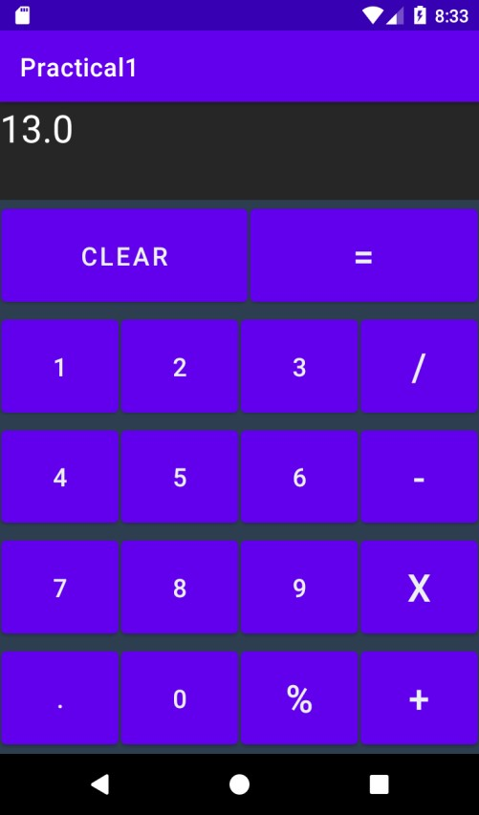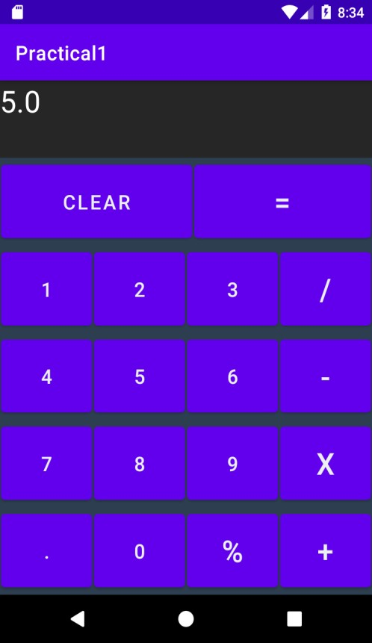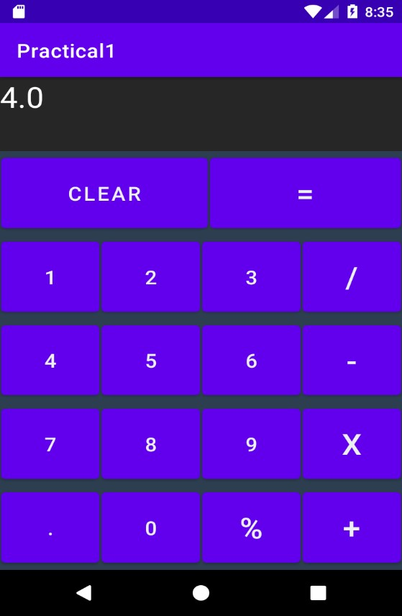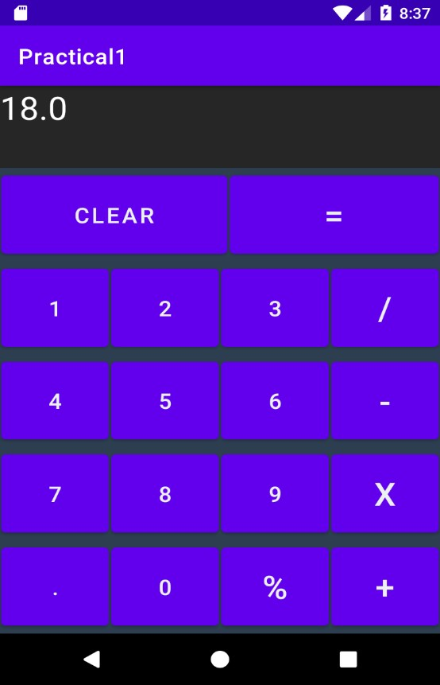

Swarangi Gawde

Android Developer Fundamentals

SY BSc CS

Div: A

TCSCCS0407P

)

(

Roll No. : 4343

26

Dividing ‘16/4’

Multiplying ‘6x3’

Dividing

‘4/0’

‘7.0+1.0’

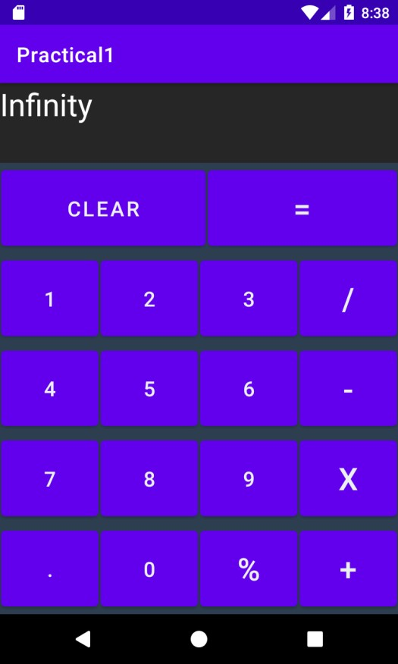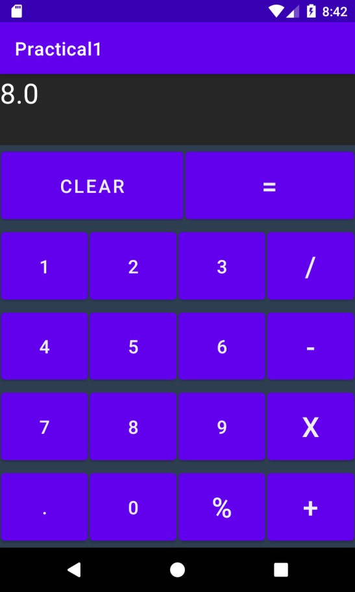

|  |  |  |
| --- | --- | --- |
| Swarangi Gawde Android Developer Fundamentals | | SY BSc CS |
| Div: A | (TCSCCS0407P) | Roll No. : 4343 |
| **Practical 3 Source Code:**  **activity_main.xml**  <?xml version="1.0" encoding="utf-8"?>  <RelativeLayout xmlns:android="http://schemas.android.com/apk/res/android" xmlns:app="http://schemas.android.com/apk/res-auto" xmlns:tools="http://schemas.android.com/tools" android:layout_width="match_parent" android:layout_height="match_parent" tools:context=".MainActivity" tools:ignore="NamespaceTypo">  <TextView android:id="@+id/txt1" android:layout_width="wrap_content" android:layout_height="wrap_content" android:layout_marginStart="30dp" android:layout_marginLeft="72dp" android:layout_marginTop="45dp" android:layout_marginEnd="30dp" android:layout_marginBottom="30dp" android:layout_toRightOf="@id/edName" android:text="Enter your name" />  <CheckBox android:id="@+id/ChkLike" android:layout_width="wrap_content" android:layout_height="wrap_content" android:layout_below="@id/edName" android:text="Do you like Android?" />  <EditText  android:id="@+id/edName" android:layout_width="wrap_content" | | 27 |

|  |  |
| --- | --- |
| Swarangi Gawde Android Developer Fundamentals | SY BSc CS |
| Div: A (TCSCCS0407P) | Roll No. : 4343 |
| android:layout_height="wrap_content" android:layout_marginLeft="-145dp" android:layout_marginTop="30dp" android:layout_marginEnd="30dp" android:layout_marginBottom="30dp" android:hint="Enter Name" />  <Button android:id="@+id/btnshow" android:layout_width="wrap_content" android:layout_height="wrap_content" android:layout_below="@id/edName" android:layout_marginTop="42dp" android:text="Click me!" />    <TextView android:id="@+id/txtAns" android:layout_below="@id/btnshow" android:layout_width="wrap_content" android:layout_height="wrap_content" android:text="" />  </RelativeLayout> | 28 |

Swarangi Gawde

Android Developer Fundamentals

SY BSc CS

Div: A

(

TCSCCS0407P

)

Roll No. : 4343

29

**MainActivity.java**

package com.example.practical3;

import androidx.a

ppcompat.app.AppCompatActivity;

import android.os.Bundle;

import android.view.View;

import android.widget.Button;

import android.widget.CheckBox;

import

android.widget.EditText;

import android.widget.TextView;

public class MainActivity extends AppCompatActivity {

private EditText ed1;

private CheckBox c1;

private Button b1;

private TextView tv1;

@Override

protected void onCreate(B

undle savedInstanceState) {

super.onCreate(savedInstanceState);

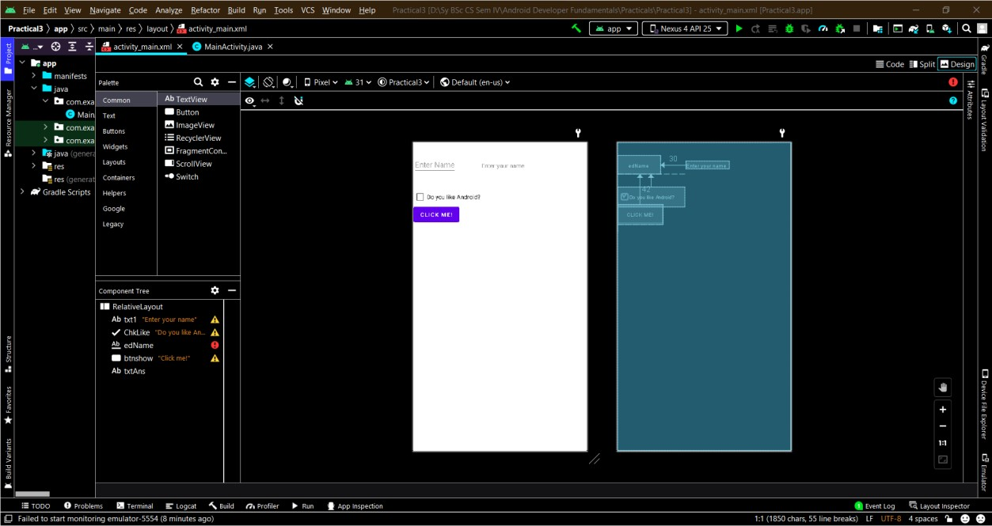

|  |  |
| --- | --- |
| Swarangi Gawde Android Developer Fundamentals | SY BSc CS |
| Div: A (TCSCCS0407P) | Roll No. : 4343 |
| setContentView(R.layout.activity_main); ed1=(EditText) findViewById(R.id.edName); c1=(CheckBox) findViewById(R.id.ChkLike); b1=(Button) findViewById(R.id.btnshow); tv1=(TextView) findViewById(R.id.txtAns);    b1.setOnClickListener(new View.OnClickListener() {  @Override  public void onClick(View v) {  StringBuilder s=new StringBuilder();  s.append("Good Morning " +ed1.getText().toString()); String temp; if(c1.isChecked()) temp="You like Android"; else  temp="You don't like Android"; s.append("\n"+temp);    tv1.setText(s.toString());  }  });  }  } | 30 |

Swarangi Gawde

Android Developer Fundamentals

SY BSc CS

Div: A

)

TCSCCS0407P

(

Roll No. : 4343

31

**Output:**

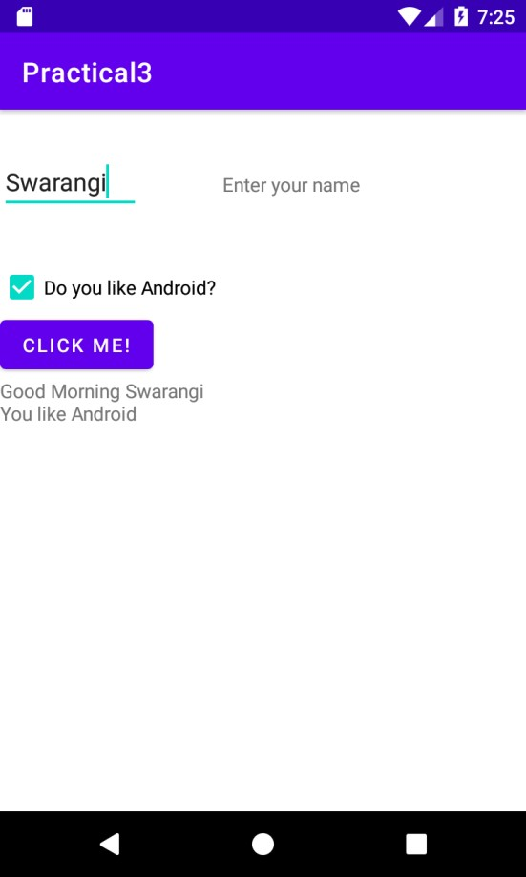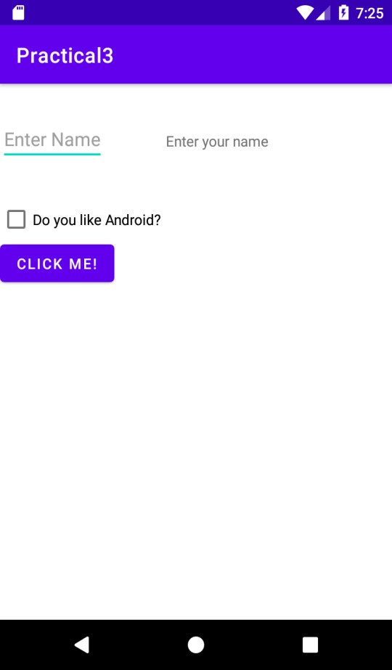

|  |  |  |
| --- | --- | --- |
| Swarangi Gawde Android Developer Fundamentals | | SY BSc CS |
| Div: A | (TCSCCS0407P) | Roll No. : 4343 |
| **Practical 4**  **Source Code:**  **activity_main.xml**  <?xml version="1.0" encoding="utf-8"?>  <androidx.constraintlayout.widget.ConstraintLayout xmlns:android="http://schemas.android.com/apk/res/android" xmlns:app="http://schemas.android.com/apk/res-auto" xmlns:tools="http://schemas.android.com/tools" android:layout_width="match_parent" android:layout_height="match_parent" tools:context=".MainActivity">    <TextView android:layout_width="wrap_content" android:layout_height="wrap_content" android:text="Hello World!" app:layout_constraintBottom_toBottomOf="parent" app:layout_constraintLeft_toLeftOf="parent" app:layout_constraintRight_toRightOf="parent" app:layout_constraintTop_toTopOf="parent" />  </androidx.constraintlayout.widget.ConstraintLayout> | | 32 |

|  |  |
| --- | --- |
| Swarangi Gawde Android Developer Fundamentals | SY BSc CS |
| Div: A (TCSCCS0407P) | Roll No. : 4343 |
| **MainActivity.java**    package com.example.practical4; import androidx.appcompat.app.AppCompatActivity; import android.app.Activity; import android.os.Bundle; import android.util.Log; public class MainActivity extends AppCompatActivity {  @Override protected void onCreate(Bundle savedInstanceState) { super.onCreate(savedInstanceState); setContentView(R.layout.activity_main);  Log.d("lifecycle","onCreate invoked");  }  @Override protected void onStart() { super.onStart();  Log.d("lifecycle","onStart invoked");  }  @Override  protected void onResume() { super.onResume();  Log.d("lifecycle","onResume invoked");  }  @Override  protected void onPause() { super.onPause();  Log.d("lifecycle","onPause invoked");  }  @Override  protected void onStop() { super.onStop(); | 33 |

Log.d("lifecycle","onStop invoked");

}

@Override protected void onRestart() { super.onRestart();

Log.d("lifecycle","onRestart invoked");

}

@Override protected void onDestroy() { super.onDestroy();

Log.d("lifecycle","onDestroy invoked");

}

}

**Output:**

You will not see any output on the emulator or device. You need to open logcat.

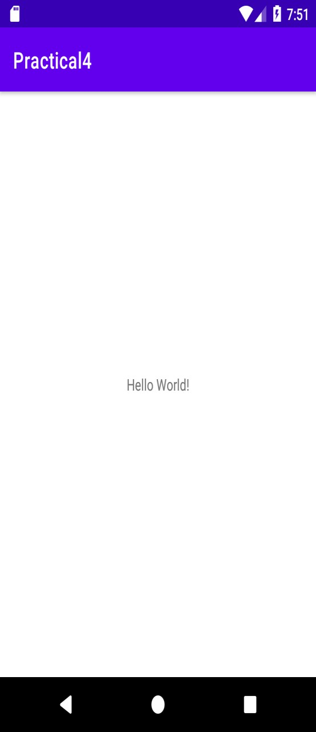

Now see on the logcat: onCreate, onStart and onResume methods are invoked.

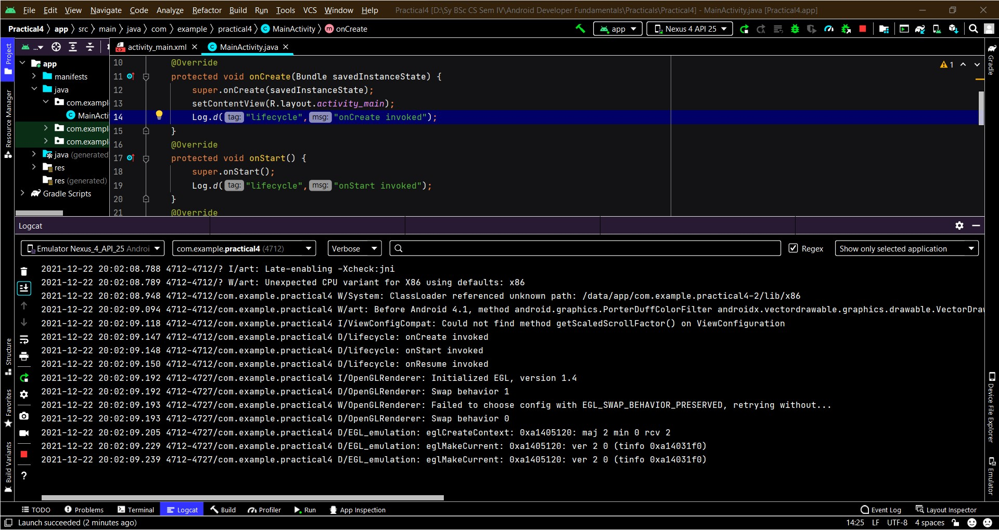

Now click on the HOME Button. You will see onPause method is invoked.

After a while, you will see onStop method is invoked.

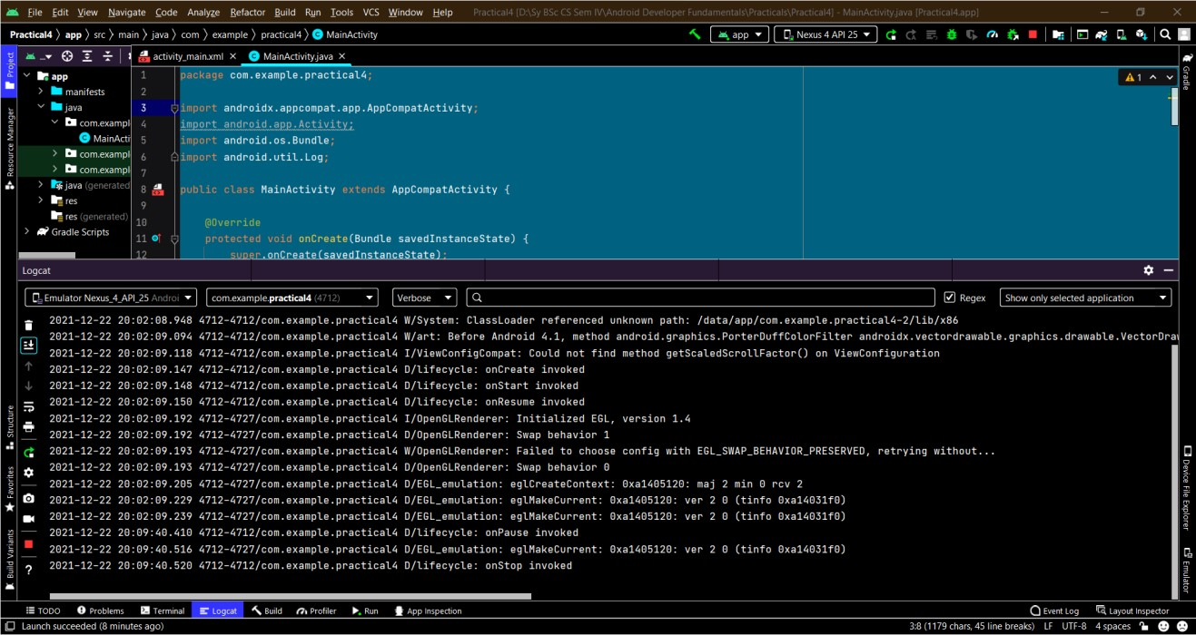

Now see on the emulator. It is on the home. Now click on the center button to launch the app again.

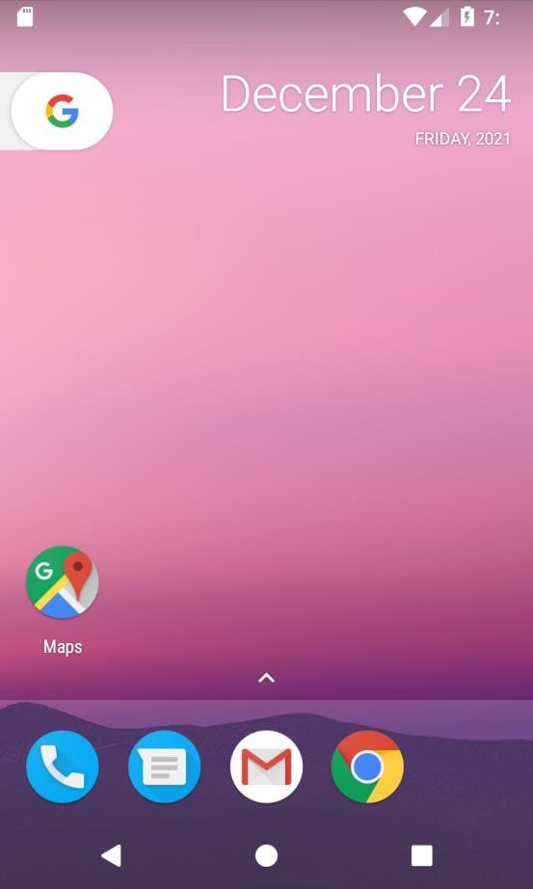

Now click on the Practical4 icon.

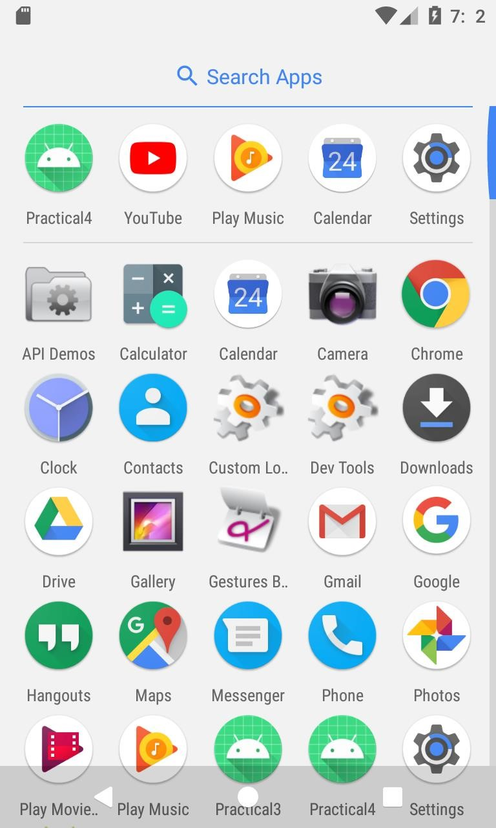

Now see on the logcat: onRestart, onStart and onResume methods are invoked.

If you see the emulator, application is started again.

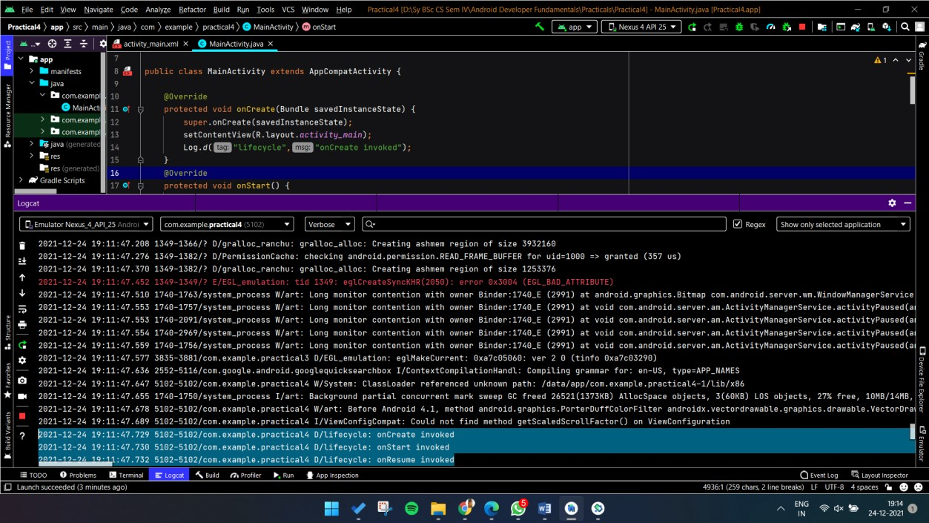

If you see the emulator, application is started again.

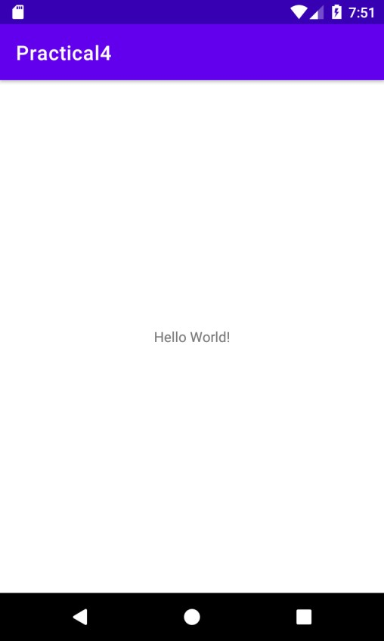

Now click on the back button. Now you will see onPause methods is invoked.

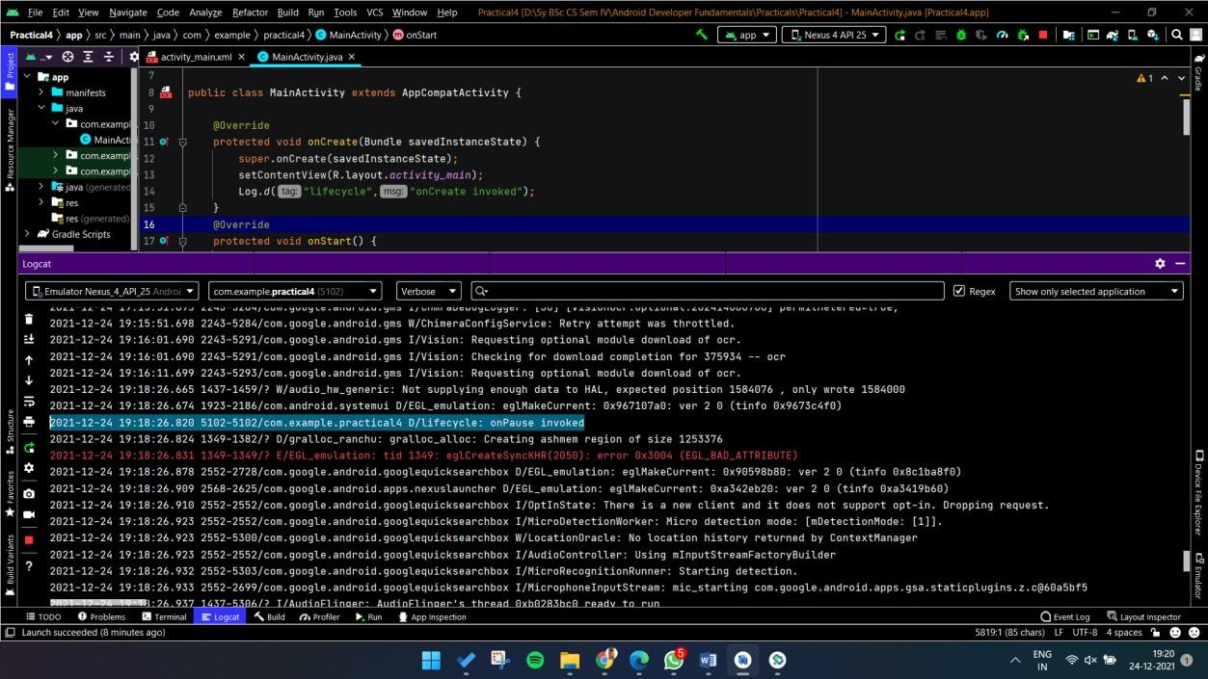

After a while, you will see onStop and onDestroy methods are invoked.

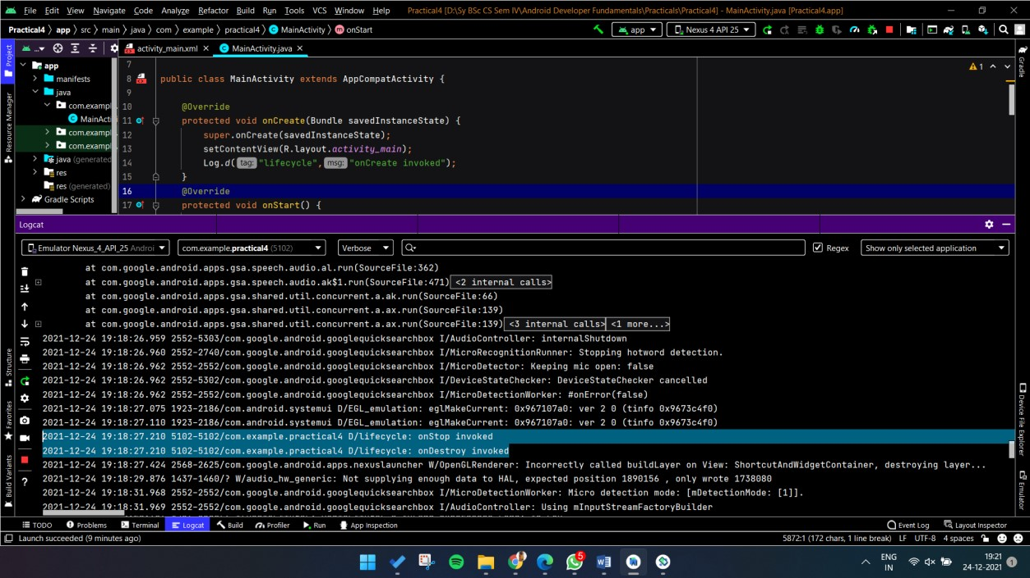

|  |  |  |
| --- | --- | --- |
| Swarangi Gawde Android Developer Fundamentals | | SY BSc CS |
| Div: A | (TCSCCS0407P) | Roll No. : 4343 |
| **Practical 05 Source Code:**  **Activity_main.xml**  <?xml version="1.0" encoding="utf-8"?>  <android.support.design.widget.CoordinatorLayout xmlns:android="http://schemas.android.com/apk/res/android" xmlns:app="http://schemas.android.com/apk/res-auto" xmlns:tools="http://schemas.android.com/tools" android:layout_width="match_parent" android:layout_height="match_parent" tools:context="com.example.android.droidcafeinput.MainActivity">    <android.support.design.widget.AppBarLayout android:layout_width="match_parent" android:layout_height="wrap_content" android:theme="@style/AppTheme.AppBarOverlay">    <android.support.v7.widget.Toolbar android:id="@+id/toolbar" android:layout_width="match_parent" android:layout_height="?attr/actionBarSize" android:background="?attr/colorPrimary" app:popupTheme="@style/AppTheme.PopupOverlay" /> </android.support.design.widget.AppBarLayout>    <include layout="@layout/content_main" />    <android.support.design.widget.FloatingActionButton android:id="@+id/fab" android:layout_width="wrap_content" android:layout_height="wrap_content" android:layout_gravity="bottom|end" | | 40 |

|  |  |
| --- | --- |
| Swarangi Gawde Android Developer Fundamentals | SY BSc CS |
| Div: A (TCSCCS0407P) | Roll No. : 4343 |
| android:layout_margin="16dp" app:srcCompat="@drawable/ic_shopping_cart" />    </android.support.design.widget.CoordinatorLayout>  Content_main.xml  <?xml version="1.0" encoding="utf-8"?>    <android.support.constraint.ConstraintLayout xmlns:android="http://schemas.android.com/apk/res/android" xmlns:app="http://schemas.android.com/apk/res-auto" xmlns:tools="http://schemas.android.com/tools" android:layout_width="match_parent" android:layout_height="match_parent" app:layout_behavior="@string/appbar_scrolling_view_behavior" tools:context="com.example.android.droidcafeinput.MainActivity" tools:showIn="@layout/activity_main" android:background="#ffe4e1">    <TextView android:id="@+id/textintro" android:layout_width="wrap_content" android:layout_height="wrap_content" android:layout_marginTop="8dp" android:text="The Comfy Cafe" android:textSize="24sp" android:textStyle="bold"  app:layout_constraintLeft_toLeftOf="parent" app:layout_constraintRight_toRightOf="parent" app:layout_constraintTop_toTopOf="parent" />    <ImageView  android:id="@+id/waffle" | 41 |

|  |  |
| --- | --- |
| Swarangi Gawde Android Developer Fundamentals | SY BSc CS |
| Div: A (TCSCCS0407P) | Roll No. : 4343 |
| android:layout_width="100dp" android:layout_height="100dp" android:layout_marginStart="24dp" android:layout_marginLeft="24dp" android:layout_marginTop="24dp" android:contentDescription="@string/donuts" android:onClick="showDonutOrder" app:layout_constraintStart_toStartOf="parent" app:layout_constraintTop_toBottomOf="@+id/textintro" app:srcCompat="@drawable/waffle" />    <ImageView android:id="@+id/panckakes" android:layout_width="106dp" android:layout_height="103dp" android:layout_marginStart="24dp" android:layout_marginLeft="24dp" android:layout_marginTop="24dp" android:contentDescription="" android:onClick="showIceCreamOrder" app:layout_constraintStart_toStartOf="parent" app:layout_constraintTop_toBottomOf="@+id/waffle" app:srcCompat="@drawable/pancakes" />    <ImageView  android:id="@+id/omlete" android:layout_width="99dp" android:layout_height="103dp" android:layout_marginStart="24dp" android:layout_marginLeft="24dp" android:layout_marginTop="12dp" android:contentDescription="@string/froyo" | 42 |

|  |
| --- |
| Swarangi Gawde Android Developer Fundamentals SY BSc CS Div: A (TCSCCS0407P) Roll No. : 4343 android:onClick="showFroyoOrder" app:layout_constraintStart_toStartOf="parent" app:layout_constraintTop_toBottomOf="@id/panckakes" app:srcCompat="@drawable/omlete" />    <TextView android:id="@+id/donut_description" android:layout_width="0dp" android:layout_height="wrap_content" android:layout_marginStart="24dp" android:layout_marginTop="4dp" android:layout_marginEnd="24dp" android:text="Waffle, crisp raised cake baked in a waffle iron, a hinged metal griddle with a honeycombed or fancifully engraved surface that allows a thin layer of batter to cook evenly and crisply." app:layout_constraintEnd_toEndOf="parent" app:layout_constraintHorizontal_bias="0.0" app:layout_constraintStart_toEndOf="@+id/waffle" app:layout_constraintTop_toTopOf="@+id/waffle" />    <TextView  android:id="@+id/ice_cream_description" android:layout_width="0dp" android:layout_height="wrap_content" android:layout_marginStart="24dp" android:layout_marginTop="28dp" android:layout_marginEnd="24dp"  android:text="A pancake is a thin, flat, circular piece of cooked batter made from milk, flour, and eggs." app:layout_constraintEnd_toEndOf="parent" app:layout_constraintHorizontal_bias="1.0" app:layout_constraintStart_toEndOf="@+id/panckakes" app:layout_constraintTop_toTopOf="@+id/panckakes" />  43 |

|  |
| --- |
| Swarangi Gawde Android Developer Fundamentals SY BSc CS Div: A (TCSCCS0407P) Roll No. : 4343    <TextView android:id="@+id/froyo_description" android:layout_width="0dp" android:layout_height="wrap_content" android:layout_marginStart="24dp" android:layout_marginTop="24dp" android:layout_marginEnd="24dp" android:text="A dish made from eggs that are mixed together, cooked without stirring, and served folded in half often with a filling of cheese, vegetables, or meat." app:layout_constraintEnd_toEndOf="parent" app:layout_constraintHorizontal_bias="0.0" app:layout_constraintStart_toEndOf="@+id/omlete" app:layout_constraintTop_toTopOf="@+id/omlete" />    <TextView android:layout_width="wrap_content" android:layout_height="wrap_content" android:layout_marginTop="544dp" android:text="Swarangi Gawde" app:layout_constraintHorizontal_bias="0.0" app:layout_constraintLeft_toLeftOf="parent" app:layout_constraintRight_toRightOf="parent" app:layout_constraintTop_toTopOf="parent" />    <TextView  android:layout_width="wrap_content" android:layout_height="wrap_content" android:layout_marginTop="568dp" android:text="Roll No : 4343" app:layout_constraintHorizontal_bias="0.0" app:layout_constraintLeft_toLeftOf="parent"  44 |

|  |  |
| --- | --- |
| Swarangi Gawde Android Developer Fundamentals | SY BSc CS |
| Div: A (TCSCCS0407P) | Roll No. : 4343 |
| app:layout_constraintRight_toRightOf="parent" app:layout_constraintTop_toTopOf="parent" />    </android.support.constraint.ConstraintLayout>    **Activity_order.xml**  <?xml version="1.0" encoding="utf-8"?> <android.support.constraint.ConstraintLayout xmlns:android="http://schemas.android.com/apk/res/android" xmlns:app="http://schemas.android.com/apk/res-auto" xmlns:tools="http://schemas.android.com/tools" android:layout_width="match_parent" android:layout_height="match_parent" tools:context="com.example.android.droidcafeinput.OrderActivity">    <TextView android:id="@+id/order_textview" android:layout_width="wrap_content" android:layout_height="wrap_content" android:layout_marginLeft="24dp" android:layout_marginStart="24dp" android:layout_marginTop="8dp" android:text="@string/order_label_text" android:textSize="18sp" app:layout_constraintStart_toStartOf="parent" app:layout_constraintTop_toTopOf="parent" />    <TextView  android:id="@+id/name_label" android:layout_width="wrap_content" android:layout_height="wrap_content" android:layout_marginLeft="24dp" | 45 |

|  |  |
| --- | --- |
| Swarangi Gawde Android Developer Fundamentals | SY BSc CS |
| Div: A (TCSCCS0407P) | Roll No. : 4343 |
| android:layout_marginStart="24dp" android:layout_marginTop="32dp" android:text="@string/name_label_text" app:layout_constraintStart_toStartOf="parent" app:layout_constraintTop_toBottomOf="@+id/order_textview" />    <EditText android:id="@+id/name_text" android:layout_width="wrap_content" android:layout_height="wrap_content" android:layout_marginLeft="8dp" android:layout_marginStart="8dp" android:ems="10" android:hint="@string/enter_name_hint" android:inputType="textPersonName" app:layout_constraintBaseline_toBaselineOf="@+id/name_label" app:layout_constraintStart_toEndOf="@+id/name_label" />    <TextView android:id="@+id/address_label" android:layout_width="wrap_content" android:layout_height="wrap_content" android:layout_marginLeft="24dp" android:layout_marginStart="24dp" android:layout_marginTop="24dp" android:text="@string/address_label_text" app:layout_constraintStart_toStartOf="parent"  app:layout_constraintTop_toBottomOf="@+id/name_label" />    <EditText  android:id="@+id/address_text" android:layout_width="wrap_content" | 46 |

|  |  |
| --- | --- |
| Swarangi Gawde Android Developer Fundamentals | SY BSc CS |
| Div: A (TCSCCS0407P) | Roll No. : 4343 |
| android:layout_height="wrap_content" android:layout_marginLeft="8dp" android:layout_marginStart="8dp" android:ems="10" android:hint="@string/enter_address_hint" android:inputType="textMultiLine" app:layout_constraintBaseline_toBaselineOf="@+id/address_label" app:layout_constraintStart_toEndOf="@+id/address_label" />    <TextView android:id="@+id/phone_label" android:layout_width="wrap_content" android:layout_height="wrap_content" android:layout_marginLeft="24dp" android:layout_marginStart="24dp" android:layout_marginTop="24dp" android:text="@string/phone_label_string" app:layout_constraintStart_toStartOf="parent" app:layout_constraintTop_toBottomOf="@+id/address_text" />    <EditText  android:id="@+id/phone_text" android:layout_width="wrap_content" android:layout_height="wrap_content" android:layout_marginLeft="8dp" android:layout_marginStart="8dp" android:ems="10"  android:hint="@string/enter_phone_hint" android:inputType="phone" app:layout_constraintBaseline_toBaselineOf="@+id/phone_label" app:layout_constraintStart_toEndOf="@+id/phone_label" /> | 47 |

|  |  |  |
| --- | --- | --- |
| Swarangi Gawde Android Developer Fundamentals | | SY BSc CS |
| Div: A | (TCSCCS0407P) | Roll No. : 4343 |
| <TextView android:id="@+id/note_label" android:layout_width="wrap_content" android:layout_height="wrap_content" android:layout_marginLeft="24dp" android:layout_marginStart="24dp" android:layout_marginTop="24dp" android:text="@string/note_label_text" app:layout_constraintStart_toStartOf="parent" app:layout_constraintTop_toBottomOf="@+id/phone_label" />    <EditText android:id="@+id/note_text" android:layout_width="wrap_content" android:layout_height="wrap_content" android:layout_marginLeft="8dp" android:layout_marginStart="8dp" android:ems="10" android:hint="@string/enter_note_hint" android:inputType="textCapSentences|textMultiLine" app:layout_constraintBaseline_toBaselineOf="@+id/note_label" app:layout_constraintStart_toEndOf="@+id/note_label" />    <TextView android:id="@+id/delivery_label" android:layout_width="wrap_content" android:layout_height="wrap_content" android:layout_marginLeft="24dp" android:layout_marginStart="24dp" android:layout_marginTop="24dp"  android:text="@string/choose_delivery_method" android:textSize="18sp" | | 48 |

|  |  |
| --- | --- |
| Swarangi Gawde Android Developer Fundamentals | SY BSc CS |
| Div: A (TCSCCS0407P) | Roll No. : 4343 |
| app:layout_constraintStart_toStartOf="parent" app:layout_constraintTop_toBottomOf="@+id/note_text" />    <RadioGroup android:layout_width="wrap_content" android:layout_height="wrap_content" android:layout_marginLeft="24dp" android:layout_marginStart="24dp" android:orientation="vertical" app:layout_constraintStart_toStartOf="parent" app:layout_constraintTop_toBottomOf="@id/delivery_label">    <RadioButton android:id="@+id/sameday" android:layout_width="wrap_content" android:layout_height="wrap_content" android:onClick="onRadioButtonClicked" android:text="@string/same_day_messenger_service" />    <RadioButton  android:id="@+id/nextday"  android:layout_width="wrap_content" android:layout_height="wrap_content" android:onClick="onRadioButtonClicked" android:text="@string/next_day_ground_delivery" android:checked="true"/>    <RadioButton  android:id="@+id/pickup" android:layout_width="wrap_content" android:layout_height="wrap_content" android:onClick="onRadioButtonClicked" | 49 |

|  |  |
| --- | --- |
| Swarangi Gawde Android Developer Fundamentals | SY BSc CS |
| Div: A (TCSCCS0407P) | Roll No. : 4343 |
| android:text="@string/pick_up" />  </RadioGroup>  </android.support.constraint.ConstraintLayout>    **Menu_main.xml**  <menu xmlns:android="http://schemas.android.com/apk/res/android" xmlns:app="http://schemas.android.com/apk/res-auto" xmlns:tools="http://schemas.android.com/tools" tools:context="com.example.android.droidcafeinput.MainActivity">  <item android:id="@+id/action_contact" android:orderInCategory="100" android:title="@string/action_contact" app:showAsAction="never" />  <item android:id="@+id/action_settings" android:orderInCategory="50" android:title="@string/settings" app:showAsAction="never" />  <item  android:id="@+id/action_order"  android:icon="@drawable/ic_shopping_cart" android:orderInCategory="10" android:title="@string/action_order" app:showAsAction="always" />  <item  android:id="@+id/action_status" android:icon="@drawable/ic_status_info" android:orderInCategory="20" android:title="@string/action_status" app:showAsAction="always" /> <item | 50 |

|  |
| --- |
| Swarangi Gawde Android Developer Fundamentals SY BSc CS Div: A (TCSCCS0407P) Roll No. : 4343 android:id="@+id/action_favorites" android:icon="@drawable/ic_favorite" android:orderInCategory="30" android:title="@string/action_favorites" app:showAsAction="ifRoom" />  </menu>    **orderActivity.java** package com.example.android.droidcafeinput; import android.content.Intent; import android.os.Bundle; import android.support.v7.app.AppCompatActivity; import android.view.View; import android.widget.RadioButton; import android.widget.TextView; import android.widget.Toast;    @Override protected void onCreate(Bundle savedInstanceState) { super.onCreate(savedInstanceState); setContentView(R.layout.activity_order);    // Get the intent and its data.  Intent intent = getIntent();  String message = intent.getStringExtra(MainActivity.EXTRA_MESSAGE); TextView textView = findViewById(R.id.order_textview); textView.setText(message);  }  public void onRadioButtonClicked(View view) { // Is the button now checked?  boolean checked = ((RadioButton) view).isChecked(); // Check which radio button was clicked.  51 |

|  |  |
| --- | --- |
| Swarangi Gawde Android Developer Fundamentals | SY BSc CS |
| Div: A (TCSCCS0407P) | Roll No. : 4343 |
| switch (view.getId()) { case R.id.sameday:  if (checked)  // Same day service displayToast( getString(R.string.same_day_messenger_service)); break; case R.id.nextday:  if (checked)  // Next day delivery displayToast(getString(R.string.next_day_ground_delivery)); break; case R.id.pickup:  if (checked) // Pick up displayToast(getString(R.string.pick_up)); break; default:  // Do nothing. break;  }  }  public void displayToast(String message) {  Toast.makeText(getApplicationContext(), message,  Toast.LENGTH_SHORT).show();  }  } | 52 |

|  |  |
| --- | --- |
| Swarangi Gawde Android Developer Fundamentals | SY BSc CS |
| Div: A (TCSCCS0407P) | Roll No. : 4343 |
| **MainActivity.java** package com.example.android.droidcafeinput; import android.content.Intent; import android.content.SharedPreferences; import android.os.Bundle; import android.preference.PreferenceManager; import android.support.design.widget.FloatingActionButton; import android.support.v7.app.AppCompatActivity; import android.support.v7.widget.Toolbar; import android.view.Menu; import android.view.MenuItem; import android.view.View; import android.widget.Toast; public class MainActivity extends AppCompatActivity {    public static final String EXTRA_MESSAGE =  "com.example.android.droidcafeinput.extra.MESSAGE"; private String mOrderMessage;  @Override protected void onCreate(Bundle savedInstanceState) { super.onCreate(savedInstanceState); setContentView(R.layout.activity_main); Toolbar toolbar = findViewById(R.id.toolbar); setSupportActionBar(toolbar);    FloatingActionButton fab = findViewById(R.id.fab); fab.setOnClickListener(new View.OnClickListener() {  @Override  public void onClick(View view) {  Intent intent = new Intent(MainActivity.this, OrderActivity.class);  intent.putExtra(EXTRA_MESSAGE, mOrderMessage); | 53 |

|  |  |
| --- | --- |
| Swarangi Gawde Android Developer Fundamentals | SY BSc CS |
| Div: A (TCSCCS0407P) | Roll No. : 4343 |
| startActivity(intent);  }  });  PreferenceManager.setDefaultValues(this,  R.xml.pref_general, false);  PreferenceManager.setDefaultValues(this,  R.xml.pref_notification, false);  PreferenceManager.setDefaultValues(this, R.xml.pref_account, false);    // Read settings from the shared preferences and display a toast.  SharedPreferences sharedPref = PreferenceManager  .getDefaultSharedPreferences(this);  String marketPref = sharedPref  .getString("sync_frequency", "-1"); displayToast(marketPref);  }  @Override public boolean onCreateOptionsMenu(Menu menu) {  // Inflate the menu; this adds items to the action bar if it is present.  getMenuInflater().inflate(R.menu.menu_main, menu); return true;  }  @Override public boolean onOptionsItemSelected(MenuItem item) { switch (item.getItemId()) { case R.id.action_order:  Intent intent = new Intent(MainActivity.this, OrderActivity.class);  intent.putExtra(EXTRA_MESSAGE, mOrderMessage); startActivity(intent); return true; | 54 |

|  |  |
| --- | --- |
| Swarangi Gawde Android Developer Fundamentals | SY BSc CS |
| Div: A (TCSCCS0407P) | Roll No. : 4343 |
| case R.id.action_settings:  Intent settingsIntent = new Intent(this, SettingsActivity.class); startActivity(settingsIntent); return true; case R.id.action_status:  displayToast(getString(R.string.action_status_message)); return true; case R.id.action_favorites:  displayToast(getString(R.string.action_favorites_message)); return true; case R.id.action_contact:  displayToast(getString(R.string.action_contact_message)); return true; default:  // Do nothing  }    return super.onOptionsItemSelected(item);  }  public void displayToast(String message) {  Toast.makeText(getApplicationContext(), message,  Toast.LENGTH_SHORT).show();  }  public void showDonutOrder(View view) {  mOrderMessage = getString(R.string.donut_order_message); displayToast(mOrderMessage);  }  public void showIceCreamOrder(View view) { mOrderMessage = getString(R.string.ice_cream_order_message); displayToast(mOrderMessage);  } | 55 |

public void showFroyoOrder(View view) { mOrderMessage = getString(R.string.froyo_order_message); displayToast(mOrderMessage);

}

}

**Output:**

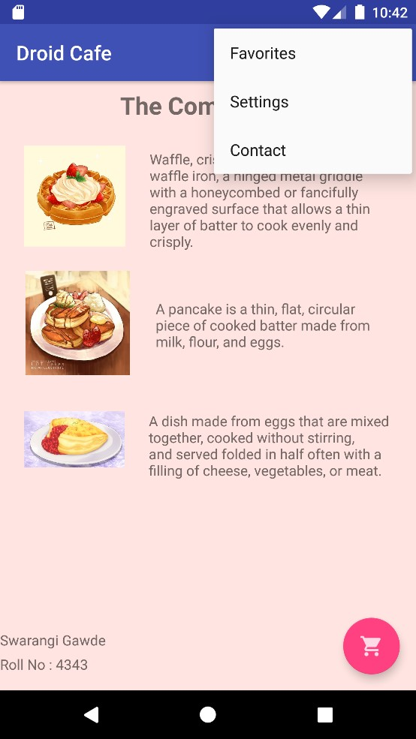 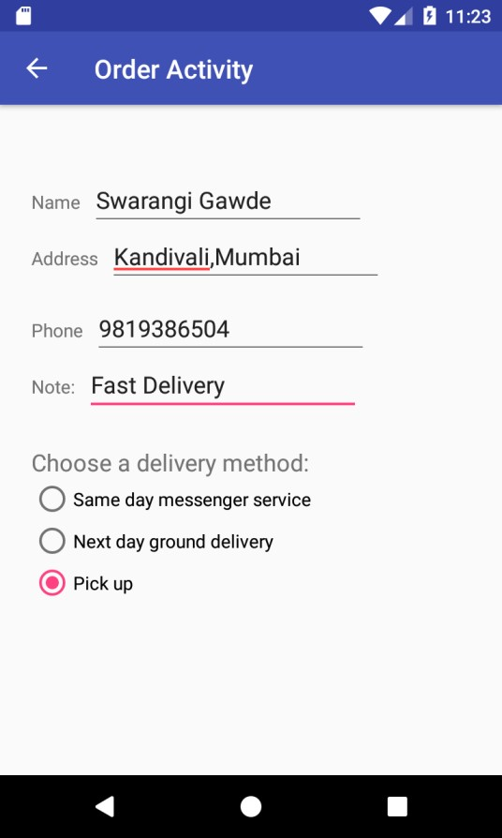

**Practical 6 Source Code:**

# Activity_main.xml

<?xml version="1.0" encoding="utf-8"?>

<RelativeLayout xmlns:android="http://schemas.android.com/apk/res/android" xmlns:app="http://schemas.android.com/apk/res-auto" xmlns:tools="http://schemas.android.com/tools" android:layout_width="match_parent"

android:layout_height="match_parent">

<TextView android:id="@+id/text" android:layout_width="wrap_content" android:layout_height="wrap_content" android:layout_centerInParent="true" android:text="Android Options Menu" android:textSize="18sp" /> </RelativeLayout>

# Menu_main.xml

<?xml version="1.0" encoding="utf-8"?>

<menu

xmlns:android="http://schemas.android.com/apk/res/android" xmlns:app="http://schemas.android.com/apk/res-auto">

<item android:id="@+id/notification"

android:title="New" />

<item android:id="@+id/help" android:title="Linked Devices" />

<item android:id="@+id/setting"

android:title="Starred Messages" />

<item android:id="@+id/logout" android:title="Settings" />

</menu>

**MainActivity.java** package com.example.practical6; import androidx.appcompat.app.AppCompatActivity;

import android.os.Bundle; import android.view.Menu; import android.view.MenuInflater; import android.view.MenuItem; import android.widget.TextView;

import android.widget.Toast;

public class MainActivity extends AppCompatActivity {

TextView text; @Override protected void onCreate(Bundle savedInstanceState) { super.onCreate(savedInstanceState); setContentView(R.layout.activity_main);

text = (TextView) findViewById(R.id.text);

}

@Override public boolean onCreateOptionsMenu(Menu menu) { MenuInflater menuInflater = getMenuInflater(); menuInflater.inflate(R.menu.menu_main, menu);

return true;

}

@Override

public boolean onOptionsItemSelected(MenuItem item) {

// Handle item click switch (item.getItemId()) { case R.id.notification:

Toast.makeText(this, "Notification", Toast.LENGTH_SHORT).show(); break; case R.id.help: makeText(this, "Help", Toast.LENGTH_SHORT).show(); break; case R.id.setting:

.makeText(this, "Setting", Toast.LENGTH_SHORT).show(); break; case R.id.logout:

Toast.makeText(this, "Logout", Toast.LENGTH_SHORT).show(); break; default: break;

} return super.onOptionsItemSelected(item);

}

}

**Output:**

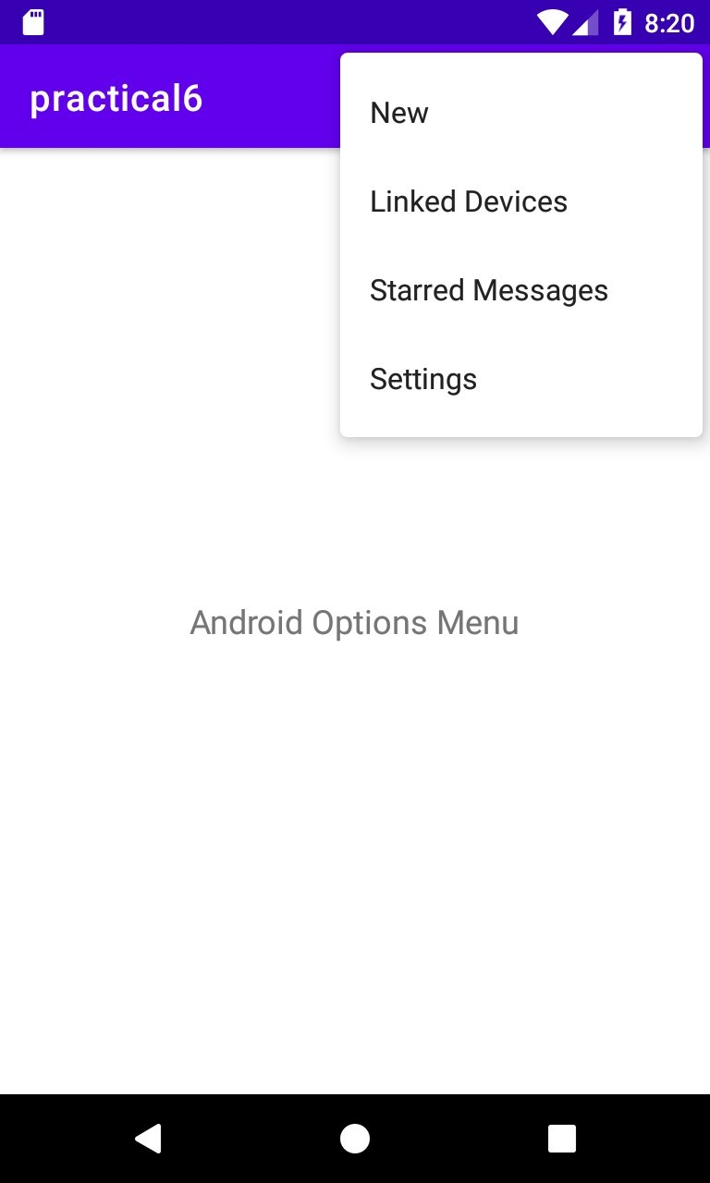

**Practical 07 Source Code:**

# Activty_main.xml

<?xml version="1.0" encoding="utf-8"?>

<RelativeLayout xmlns:android="http://schemas.android.com/apk/res/android" xmlns:app="http://schemas.android.com/apk/res-auto" xmlns:tools="http://schemas.android.com/tools" android:id="@+id/activity_main" android:layout_width="match_parent" android:layout_height="match_parent" tools:context="com.example.android.tabexperiment.MainActivity">

<android.support.v7.widget.Toolbar android:id="@+id/toolbar" android:layout_width="match_parent" android:layout_height="wrap_content" android:layout_alignParentTop="true" android:background="#070130" android:minHeight="?attr/actionBarSize" app:titleTextColor="#eeeeee"

app:popupTheme="@style/ThemeOverlay.AppCompat.Light" />

<android.support.design.widget.TabLayout android:id="@+id/tab_layout" android:layout_width="match_parent" android:layout_height="wrap_content" android:layout_below="@id/toolbar" android:background=" #3b114f" android:theme="@style/ThemeOverlay.AppCompat.Dark.ActionBar" />

<android.support.v4.view.ViewPager

android:id="@+id/pager" android:layout_width="match_parent" android:layout_height="fill_parent" android:layout_below="@id/tab_layout"/>

</RelativeLayout>

# Tab_fragment1.xml

<RelativeLayout xmlns:android="http://schemas.android.com/apk/res/android" xmlns:tools="http://schemas.android.com/tools" android:layout_width="match_parent" android:layout_height="match_parent" tools:context="com.example.android.tabexperiment.TabFragment1" android:background="#f4cccc">

<TextView android:layout_width="wrap_content" android:layout_height="wrap_content" android:text="Assignment1" android:layout_marginTop="45dp" android:textAppearance="?android:attr/textAppearanceLarge"/>

<TextView

android:layout_width="wrap_content" android:layout_height="wrap_content" android:text="Roll no : 4343" android:layout_marginTop="400dp"

android:textAppearance="?android:attr/textAppearanceLarge"/>

</RelativeLayout>

# Tab_fragment2.xml

<RelativeLayout xmlns:android="http://schemas.android.com/apk/res/android" xmlns:tools="http://schemas.android.com/tools" android:layout_width="match_parent" android:layout_height="match_parent" tools:context="com.example.android.tabexperiment.TabFragment2" android:background="#fce5cd">

<TextView android:layout_width="wrap_content" android:layout_height="wrap_content" android:text="Android Attendace : 87" android:textAppearance="?android:attr/textAppearanceLarge"/>

</RelativeLayout>

# Tab_fragment3.xml

<RelativeLayout xmlns:android="http://schemas.android.com/apk/res/android" xmlns:tools="http://schemas.android.com/tools" android:layout_width="match_parent" android:layout_height="match_parent" tools:context="com.example.android.tabexperiment.TabFragment3" android:background="#fff2cc">

<TextView android:layout_width="wrap_content" android:layout_height="wrap_content" android:text="Android Assignment 1"

android:textAppearance="?android:attr/textAppearanceLarge"/>

</RelativeLayout>

# Strings.xml

<resources>

<string name="app_name">Screen navigation</string>

<string name="tab_1">Profile</string>

<string name="tab_2">Results out!!</string>

<string name="tab_3">Android: 85</string>

<string name="tab_label1">Assignments</string>

<string name="tab_label2">Attendance</string>

<string name="tab_label3">Assignments</string>

</resources>

**MainActivity.java** package com.example.android.tabexperiment; import android.os.Bundle; import android.support.design.widget.TabLayout; import android.support.v4.view.ViewPager; import android.support.v7.app.AppCompatActivity; public class MainActivity extends AppCompatActivity {

@Override protected void onCreate(Bundle savedInstanceState) { super.onCreate(savedInstanceState); setContentView(R.layout.activity_main); android.support.v7.widget.Toolbar toolbar = findViewById(R.id.toolbar); setSupportActionBar(toolbar);

// Create an instance of the tab layout from the view. TabLayout tabLayout = findViewById(R.id.tab_layout); // Set the text for each tab.

tabLayout.addTab(tabLayout.newTab().setText(R.string.tab_label1)); tabLayout.addTab(tabLayout.newTab().setText(R.string.tab_label2)); tabLayout.addTab(tabLayout.newTab().setText(R.string.tab_label3));

// Set the tabs to fill the entire layout.

|  |  |
| --- | --- |
| Swarangi Gawde Android Developer Fundamentals | SY BSc CS |
| Div: A (TCSCCS0407P) | Roll No. : 4343 |
| tabLayout.setTabGravity(TabLayout.GRAVITY_FILL);    // Use PagerAdapter to manage page views in fragments.  // Each page is represented by its own fragment. final ViewPager viewPager = findViewById(R.id.pager); final PagerAdapter adapter = new PagerAdapter  (getSupportFragmentManager(), tabLayout.getTabCount()); viewPager.setAdapter(adapter);    // Setting a listener for clicks.  viewPager.addOnPageChangeListener(new  TabLayout.TabLayoutOnPageChangeListener(tabLayout)); tabLayout.addOnTabSelectedListener( new TabLayout.OnTabSelectedListener() {  @Override public void onTabSelected(TabLayout.Tab tab) { viewPager.setCurrentItem(tab.getPosition());  }    @Override  public void onTabUnselected(TabLayout.Tab tab) {  }    @Override public void onTabReselected(TabLayout.Tab tab) {  }  });  }  } | 64 |

|  |  |
| --- | --- |
| Swarangi Gawde Android Developer Fundamentals | SY BSc CS |
| Div: A (TCSCCS0407P) | Roll No. : 4343 |
| **PagerAdapter.java** package com.example.android.tabexperiment; import android.support.v4.app.Fragment; import android.support.v4.app.FragmentManager; import android.support.v4.app.FragmentStatePagerAdapter; public class PagerAdapter extends FragmentStatePagerAdapter { int mNumOfTabs; public PagerAdapter(FragmentManager fm, int NumOfTabs) { super(fm);  this.mNumOfTabs = NumOfTabs;  }  @Override public Fragment getItem(int position) { switch (position) { case 0: return new TabFragment1(); case 1: return new TabFragment2(); case 2: return new TabFragment3(); default: return null;  }  }  @Override  public int getCount() { return mNumOfTabs;  }  }    **TabFragment1.java**  package com.example.android.tabexperiment; import android.os.Bundle; import android.support.v4.app.Fragment; import android.view.LayoutInflater; import android.view.View; | 65 |

|  |  |
| --- | --- |
| Swarangi Gawde Android Developer Fundamentals | SY BSc CS |
| Div: A (TCSCCS0407P) | Roll No. : 4343 |
| import android.view.ViewGroup; public class TabFragment1 extends Fragment { public TabFragment1() {  // Required empty public constructor  }  @Override  public View onCreateView(LayoutInflater inflater, ViewGroup container,  Bundle savedInstanceState) { // Inflate the layout for this fragment.  return inflater.inflate(R.layout.tab_fragment1, container, false); }}    **TabFragment2.java** package com.example.android.tabexperiment; import android.os.Bundle; import android.support.v4.app.Fragment; import android.view.LayoutInflater; import android.view.View; import android.view.ViewGroup; public class TabFragment2 extends Fragment { public TabFragment2() {  // Required empty public constructor  }  @Override  public View onCreateView(LayoutInflater inflater, ViewGroup container,  Bundle savedInstanceState) { // Inflate the layout for this fragment  return inflater.inflate(R.layout.tab_fragment2, container, false);  }  } | 66 |

|  |  |
| --- | --- |
| Swarangi Gawde Android Developer Fundamentals | SY BSc CS |
| Div: A (TCSCCS0407P) | Roll No. : 4343 |
| **TabFragment3.java** package com.example.android.tabexperiment; import android.os.Bundle; import android.support.v4.app.Fragment; import android.view.LayoutInflater; import android.view.View; import android.view.ViewGroup; public class TabFragment3 extends Fragment { public TabFragment3() {  // Required empty public constructor  }  @Override  public View onCreateView(LayoutInflater inflater, ViewGroup container,  Bundle savedInstanceState) { // Inflate the layout for this fragment return inflater.inflate(R.layout.tab_fragment3, container, false);  } | 67 |

Swarangi Gawde

Android Developer Fundamentals

SY BSc CS

Div: A

(

TCSCCS0407P

)

Roll No. : 4343

68

**Output:**

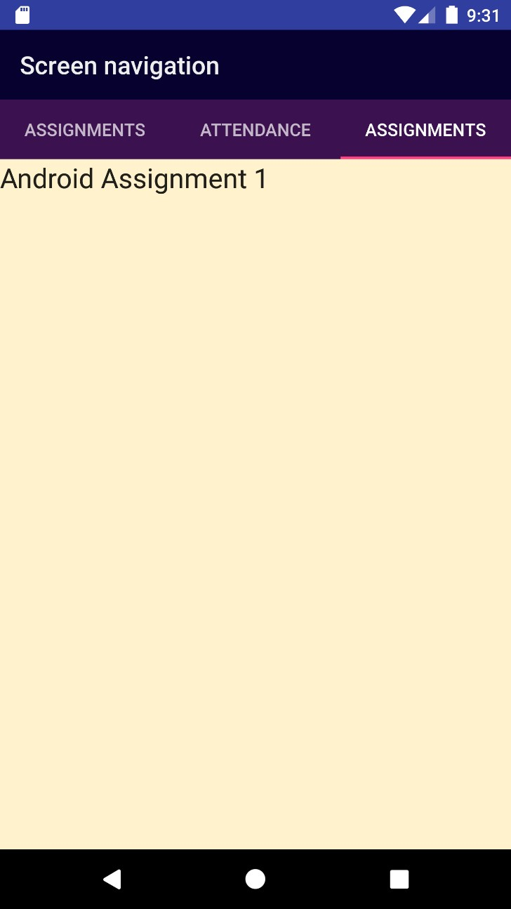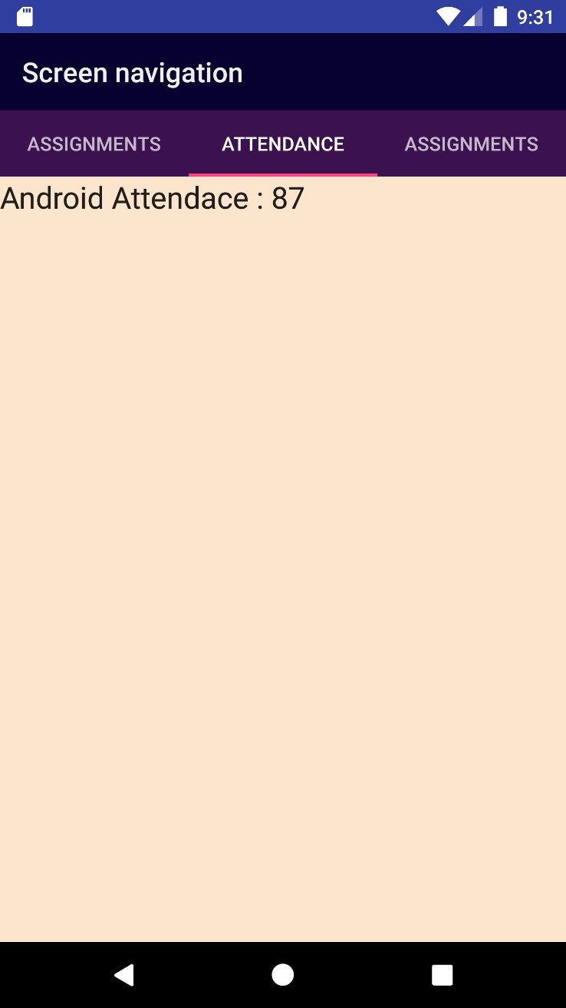

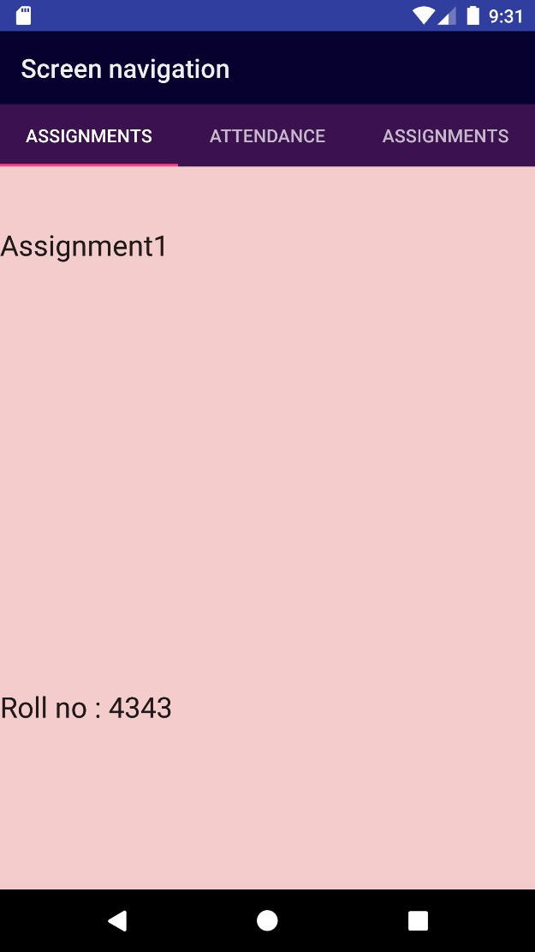

|  |  |
| --- | --- |
| Swarangi Gawde Android Developer Fundamentals | SY BSc CS |
| Div: A (TCSCCS0407P) | Roll No. : 4343 |
| **Practical 08 Source Code:**  **Activity_main.xml**  <?xml version="1.0" encoding="utf-8"?>  <LinearLayout  xmlns:android="http://schemas.android.com/apk/res/android" android:layout_width="match_parent" android:layout_height="match_parent" android:background="#89CFF0" android:orientation="vertical">  <Button android:id="@+id/sendBroadcast" android:layout_width="wrap_content" android:layout_height="wrap_content" android:layout_marginTop="200dp" android:layout_marginLeft="95dp" android:onClick="sendCustomBroadcast" android:text="@string/send_custom_broadcast" />  <TextView android:layout_width="wrap_content" android:layout_height="wrap_content" android:text="SwarangiGawde"  android:layout_marginTop="200dp"></TextView>  <TextView android:layout_width="wrap_content" android:layout_height="wrap_content" android:text="Roll No : 4343" ></TextView>  </LinearLayout>    **AndroidManisfest.xml**  <?xml version="1.0" encoding="utf-8"?>  <manifest  xmlns:android="http://schemas.android.com/apk/res/android" package="com.android.fundamentals.powerreceiver">    <application android:allowBackup="true" android:icon="@mipmap/ic_launcher" android:label="@string/app_name"  android:roundIcon="@mipmap/ic_launcher_round" android:supportsRtl="true" | 70 |

android:theme="@style/AppTheme">

<activity android:name=".MainActivity">

<intent-filter>

<action android:name="android.intent.action.MAIN" />

<category android:name="android.intent.category.LAUNCHER" />

</intent-filter>

</activity>

</application>

</manifest>

# Strings.xml

<resources>

<string name="app_name">PowerReceiver</string>

<string name="power_connected">Power connected!</string>

<string name="power_disconnected">Power disconnected!</string>

<string name="custom_broadcast_toast">Custom Broadcast Received</string>

<string name="send_custom_broadcast">Send Custom Broadcast</string>

<string name="receiver_on">Receiver On</string>

<string name="receiver_off">Receiver Off</string>

<string name="unknown_action">unknown intent action</string>

</resources>

# MainActivity.java package

com.android.fundamentals.powerreceiver; import android.content.Intent; import android.content.IntentFilter;

import android.support.v4.content.LocalBroadcastManager; import android.support.v7.app.AppCompatActivity; import android.os.Bundle;

import android.view.View; import android.widget.Toast; public class MainActivity extends AppCompatActivity { private CustomReceiver Receiver = new CustomReceiver(); private static final String ACTION_CUSTOM_BROADCAST =

BuildConfig.APPLICATION_ID + ".ACTION_CUSTOM_BROADCAST";

@Override protected void onCreate(Bundle savedInstanceState) { super.onCreate(savedInstanceState); setContentView(R.layout.activity_main); IntentFilter filter = new IntentFilter();

filter.addAction(Intent.ACTION_POWER_CONNECTED); filter.addAction(Intent.ACTION_POWER_DISCONNECTED);

filter.addAction(Intent.ACTION_BATTERY_LOW); this.registerReceiver(Receiver, filter);

LocalBroadcastManager.getInstance(this).registerReceiver

(Receiver, new IntentFilter(ACTION_CUSTOM_BROADCAST));

}

public void sendCustomBroadcast(View view) {

Toast.makeText(this,"Good morning:", Toast.LENGTH_LONG).show();

Intent customBroadcastIntent = new Intent(ACTION_CUSTOM_BROADCAST);

LocalBroadcastManager.getInstance(this).sendBroadcast(customBroadcastIntent);

}

@Override protected void onDestroy() { this.unregisterReceiver(Receiver);

LocalBroadcastManager.getInstance(this).unregisterReceiver(Receiver); super.onDestroy();

}

}

# CustomReceiver.java

packagecom.android.fundamentals.powerreceiver; import android.content.BroadcastReceiver; import android.content.Context; import android.content.Intent; import android.widget.Toast; public class CustomReceiver extends BroadcastReceiver { // String constant that defines the custom broadcast Action. private static final String ACTION_CUSTOM_BROADCAST =

BuildConfig.APPLICATION_ID + ".ACTION_CUSTOM_BROADCAST";

@Override public void onReceive(Context context, Intent intent) { String intentAction = intent.getAction(); if (intentAction != null) {

String toastMessage =

context.getString(R.string.unknown_action); switch (intentAction)

{ case Intent.ACTION_POWER_CONNECTED:

toastMessage =context.getString(R.string.power_connected); break; case Intent.ACTION_BATTERY_LOW:

toastMessage = "Please connect charger now. Battery is low!"; break; case Intent.ACTION_POWER_DISCONNECTED:

toastMessage = context.getString(R.string.power_disconnected); break;

}

Toast.makeText(context, toastMessage, Toast.LENGTH_LONG).show();

}

}

}

**Output:**

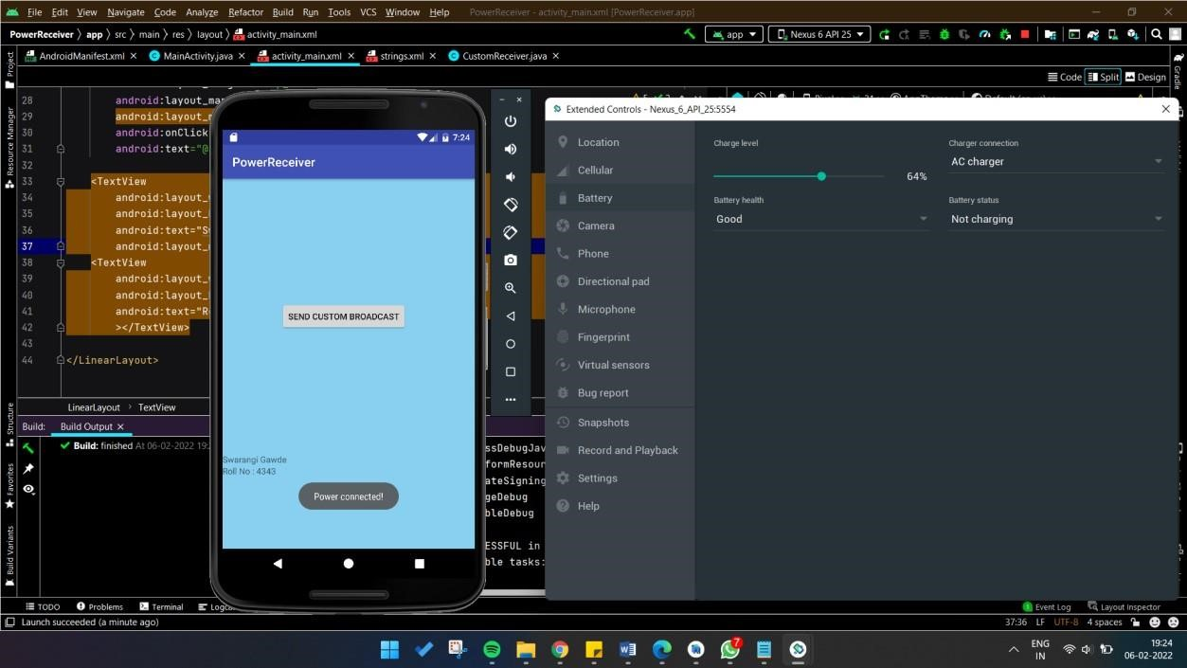

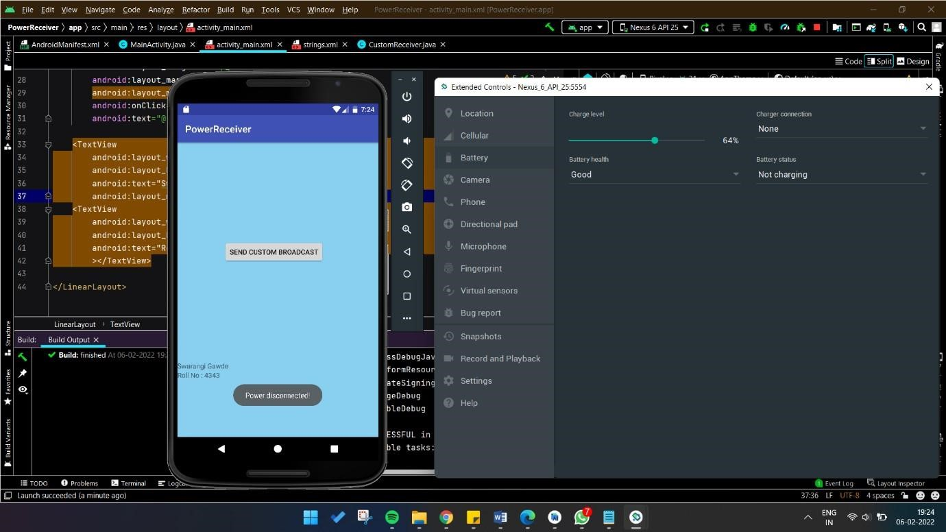

**Practical 09 Source Code:**

# Activity_main.xml

<?xml version="1.0" encoding="utf-8"?>

<RelativeLayout xmlns:android="http://schemas.android.com/apk/res/android" xmlns:app="http://schemas.android.com/apk/res-auto" xmlns:tools="http://schemas.android.com/tools" android:layout_width="match_parent" android:layout_height="match_parent" tools:context=".MainActivity" android:background="#FFF0F5">

<Button android:id="@+id/button" android:layout_width="wrap_content" android:layout_height="wrap_content" android:backgroundTint="#DE98B2" android:text="Set Alarm" android:layout_alignParentBottom="true" android:layout_centerHorizontal="true" android:layout_marginBottom="103dp" />

<EditText

android:id="@+id/time" android:layout_width="wrap_content" android:layout_height="wrap_content" android:layout_alignParentTop="true" android:layout_centerHorizontal="true" android:layout_marginTop="22dp" android:ems="7" /> <TextView android:layout_width="wrap_content" android:layout_height="wrap_content" android:layout_marginTop="30dp"

|  |  |
| --- | --- |
| Swarangi Gawde Android Developer Fundamentals | SY BSc CS |
| Div: A (TCSCCS0407P) | Roll No. : 4343 |
| android:textSize="18dp" android:text="Alarm to ring in:"></TextView>  <TextView android:layout_width="wrap_content" android:layout_height="wrap_content" android:layout_marginLeft="300dp" android:layout_marginTop="30dp" android:textSize="18dp" android:text="seconds"></TextView>  <TextView android:layout_width="wrap_content" android:layout_height="wrap_content" android:layout_alignParentBottom="true" android:layout_marginBottom="110dp" android:textSize="16dp" android:text="Swarangi Gawde"></TextView>  <TextView android:layout_width="wrap_content" android:layout_height="wrap_content" android:layout_alignParentBottom="true" android:layout_marginBottom="90dp" android:textSize="16dp" android:text="Roll No : 4343">  </TextView>  </RelativeLayout> | 76 |

|  |  |
| --- | --- |
| Swarangi Gawde Android Developer Fundamentals | SY BSc CS |
| Div: A (TCSCCS0407P) | Roll No. : 4343 |
| **AndroidManifest.xml**  <?xml version="1.0" encoding="utf-8"?>  <manifest xmlns:android="http://schemas.android.com/apk/res/android" package="com.example.practical9">  <application android:allowBackup="true" android:icon="@mipmap/ic_launcher" android:label="@string/app_name" android:roundIcon="@mipmap/ic_launcher_round" android:supportsRtl="true" android:theme="@style/Theme.Practical9">  <receiver android:name=".MyBroadcastReceiver" android:enabled="true" android:exported="true"></receiver>  <activity android:name=".MainActivity" android:exported="true">  <intent-filter>  <action android:name="android.intent.action.MAIN" />  <category android:name="android.intent.category.LAUNCHER" />  </intent-filter>  </activity>  </application>  </manifest> | 77 |

**MyBroadcastReceiver.java** package com.example.practical9; import android.content.BroadcastReceiver; import android.content.Context; import android.content.Intent; import android.media.MediaPlayer; import android.widget.Toast; public class MyBroadcastReceiver extends BroadcastReceiver {

@Override public void onReceive(Context context, Intent intent) { final MediaPlayer mp = MediaPlayer.create(context, R.raw.alarm_beeps); mp.start();

Toast.makeText(context, "Alarm....", Toast.LENGTH_LONG).show();

}

}

**MainActivity.java** package com.example.practical9; import androidx.appcompat.app.AppCompatActivity; import android.app.AlarmManager; import android.app.PendingIntent; import android.content.Intent; import android.os.Bundle; import android.view.View; import android.widget.Button; import android.widget.EditText; import android.widget.Toast;

public class MainActivity extends AppCompatActivity {

Button start; @Override protected void onCreate(Bundle savedInstanceState) {

super.onCreate(savedInstanceState); setContentView(R.layout.activity_main); start= findViewById(R.id.button); start.setOnClickListener(new View.OnClickListener() {

@Override public void onClick(View view) { startAlert();

}

});

}

public void startAlert(){

EditText text = findViewById(R.id.time); int i = Integer.parseInt(text.getText().toString());

Intent intent = new Intent(this, MyBroadcastReceiver.class);

PendingIntent pendingIntent = PendingIntent.getBroadcast(getApplicationContext(), 0, intent, 0);

AlarmManager alarmManager = (AlarmManager) getSystemService(ALARM_SERVICE); alarmManager.set(AlarmManager.RTC_WAKEUP, System.currentTimeMillis()

+ (i * 1000), pendingIntent);

Toast.makeText(this, "Alarm set in " + i + " seconds", Toast.LENGTH_LONG).show();

}

}

**Output:**

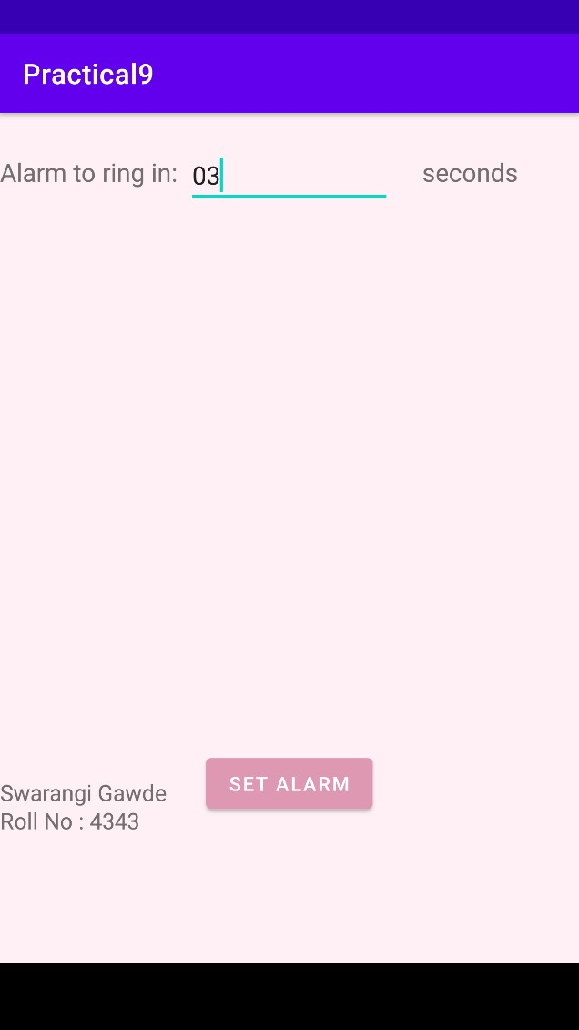 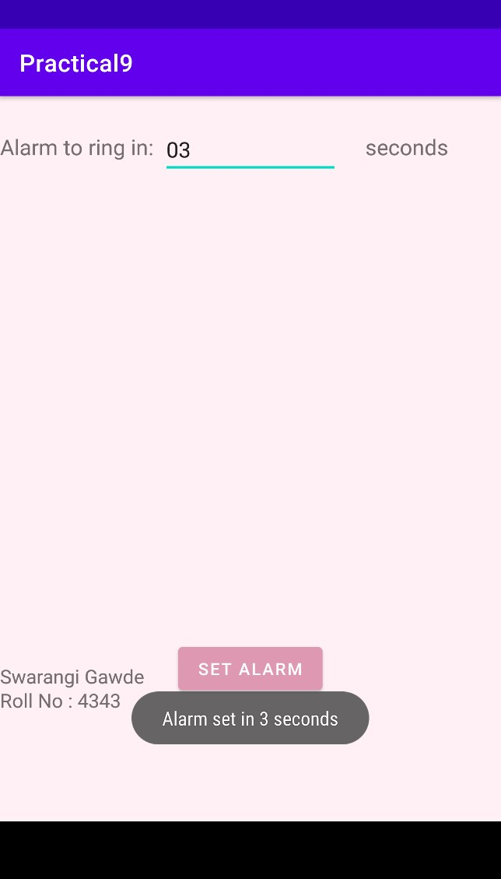

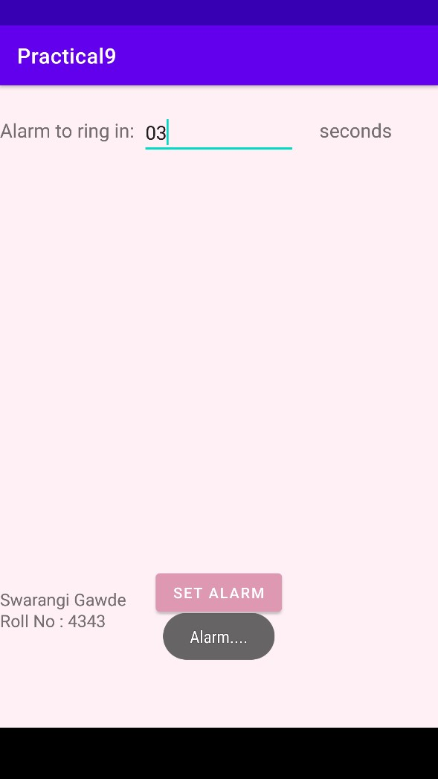

|  |  |  |
| --- | --- | --- |
| Swarangi Gawde Android Developer Fundamentals | | SY BSc CS |
| Div: A | (TCSCCS0407P) | Roll No. : 4343 |
| **Practical 10**  **Source Code:**  **Activity_main.xml**  <?xml version="1.0" encoding="utf-8"?>  <LinearLayout xmlns:android="http://schemas.android.com/apk/res/android" xmlns:app="http://schemas.android.com/apk/res-auto" xmlns:tools="http://schemas.android.com/tools" android:layout_width="match_parent" android:layout_height="match_parent" android:orientation="vertical" android:background="#add8e6" tools:context="com.example.swarangi.sqlitedemo.MainActivity">  <TextView android:layout_width="wrap_content" android:layout_height="wrap_content" android:textSize="30dp" android:text="UserName" />    <EditText  android:id="@+id/userNameValue" android:layout_width="386dp" android:layout_height="wrap_content" android:textSize="30dp" />  <TextView android:layout_width="wrap_content" android:layout_height="wrap_content" android:textSize="30dp" android:text="Password" />    <EditText android:id="@+id/passwordValue" | | 82 |

|  |  |
| --- | --- |
| Swarangi Gawde Android Developer Fundamentals | SY BSc CS |
| Div: A (TCSCCS0407P) | Roll No. : 4343 |
| android:layout_width="355dp" android:layout_height="wrap_content" android:inputType="textPassword" android:textSize="30dp" />      <LinearLayout android:layout_width="match_parent" android:layout_height="wrap_content">    <Button android:id="@+id/button" android:layout_width="114dp" android:layout_height="wrap_content" android:layout_gravity="center" android:layout_margin="45dp" android:layout_weight="0." android:onClick="addUser" android:text="Add User" />    <Button android:id="@+id/button2" android:layout_width="137dp" android:layout_height="wrap_content" android:layout_gravity="center" android:onClick="viewDetails" android:text="View Details" />  </LinearLayout> <TextView android:layout_width="wrap_content" android:layout_height="wrap_content" | 83 |

|  |  |
| --- | --- |
| Swarangi Gawde Android Developer Fundamentals | SY BSc CS |
| Div: A (TCSCCS0407P) | Roll No. : 4343 |
| android:text="Enter Username and Password"></TextView>  <EditText android:id="@+id/name" android:layout_width="354dp" android:layout_height="wrap_content" android:textSize="30dp" />    <LinearLayout android:layout_width="match_parent" android:layout_height="wrap_content"  >    <Button android:id="@+id/button3" android:layout_width="wrap_content" android:layout_height="wrap_content" android:layout_gravity="center" android:onClick="getDetails" android:layout_margin="20dp" android:text="Get Details" />    <Button android:id="@+id/button4" android:layout_width="wrap_content" android:layout_height="wrap_content" android:layout_gravity="center" android:onClick="update" android:layout_margin="20dp" android:text="Update" />    <Button | 84 |

|  |  |
| --- | --- |
| Swarangi Gawde Android Developer Fundamentals | SY BSc CS |
| Div: A (TCSCCS0407P) | Roll No. : 4343 |
| android:id="@+id/button5" android:layout_width="104dp" android:layout_height="wrap_content" android:layout_gravity="center" android:layout_margin="2dp" android:onClick="delete" android:text="Delete" />  </LinearLayout>  </LinearLayout>    **DCSDatabaseAdapter.java** package com.example.sqlitedemo;    import android.content.ContentValues; import android.content.Context; import android.database.Cursor; import android.database.sqlite.SQLiteDatabase; import android.database.sqlite.SQLiteOpenHelper; import android.widget.Toast;    import java.sql.SQLException;    public class DCSDatabaseAdapter {  DCSHelper helper;    public DCSDatabaseAdapter(Context context) { helper = new DCSHelper(context);  }    public long insertData(String name, String password) {  SQLiteDatabase db = helper.getWritableDatabase(); | 85 |

ContentValues contentValues = new ContentValues(); contentValues.put(DCSHelper.NAME, name); contentValues.put(DCSHelper.PASSWORD, password); long id = db.insert(DCSHelper.TABLE_NAME, null, contentValues);

return id;

}

public String getAllData() {

SQLiteDatabase db = helper.getWritableDatabase();

//SELECT _id,Name,Password from DCSTABLE;

String[] columns = {DCSHelper.UID, DCSHelper.NAME, DCSHelper.PASSWORD};

Cursor cursor = db.query(DCSHelper.TABLE_NAME, columns, null, null, null, null, null); StringBuffer buffer = new StringBuffer();

while (cursor.moveToNext()) {

int cid = cursor.getInt(0);

String name = cursor.getString(1); String password = cursor.getString(2); buffer.append(cid + " " + name + " " + password + "\n");

}

return buffer.toString();

}

public String getData(String name, String password) {

SQLiteDatabase db = helper.getWritableDatabase();

//SELECT name, password from DCSTABLE WHERE NAME='Raj';

//SELECT _id from DCSTABLE WHERE NAME=? AND password=?;

String[] columns = {DCSHelper.UID, DCSHelper.NAME, DCSHelper.PASSWORD};

String[] selectionArgs = {name, password};

//Cursor cursor = db.query(DCSHelper.TABLE_NAME, columns, DCSHelper.NAME + "='"+name+"'", null, null, null, null);

Cursor cursor = db.query(DCSHelper.TABLE_NAME, columns, DCSHelper.NAME + "=? AND " + DCSHelper.PASSWORD + "=?", selectionArgs, null, null, null, null); StringBuffer buffer = new StringBuffer(); while (cursor.moveToNext()) { int index0 = cursor.getColumnIndex(DCSHelper.UID); int personId = cursor.getInt(index0);

//int index1 = cursor.getColumnIndex(DCSHelper.NAME);

//int index2 = cursor.getColumnIndex(DCSHelper.PASSWORD);

//String password = cursor.getString(index2); buffer.append(personId + "\n");

//buffer.append(name + " " + password + "\n");

}

return buffer.toString();

}

public int updateName(String oldName, String newName) {

//UPDATE DCSTABLE SET Name='Raj from TY' WHERE Name='Raj';

SQLiteDatabase db = helper.getWritableDatabase(); ContentValues contentValues = new ContentValues(); contentValues.put(DCSHelper.NAME, newName); String[] whereArgs = {oldName};

int count = db.update(DCSHelper.TABLE_NAME, contentValues, DCSHelper.NAME + " =? ", whereArgs);

return count;

}

public int deleteRow() {

//DELETE * FROM DCSTABLE WHERE Name='Swarangi';

SQLiteDatabase db = helper.getWritableDatabase(); String[] whereArgs = {"Swarangi"};

int count = db.delete(DCSHelper.TABLE_NAME, DCSHelper.NAME + "=?", whereArgs);

return count;

}

static class DCSHelper extends SQLiteOpenHelper { private static final String DATABASE_NAME = "dcsdatabase7"; private static final String TABLE_NAME = "DCSTABLE"; private static final int DATABASE_VERSION = 1; private static final String UID = "_id"; private static final String NAME = "Name"; private static final String PASSWORD = "Password";

private static final String CREATE_TABLE = "CREATE TABLE " + TABLE_NAME + " (" + UID + "

INTEGER PRIMARY KEY AUTOINCREMENT, " + NAME + " VARCHAR(255), " + PASSWORD + " VARCHAR(255));"; private static final String DROP_TABLE = "DROP TABLE IF EXISTS " + TABLE_NAME + ";"; private Context context;

public DCSHelper(Context context) { super(context, DATABASE_NAME, null, DATABASE_VERSION);

this.context = context;

Message.message(context, "constructor called...");

}

@Override public void onCreate(SQLiteDatabase db) {

try {

db.execSQL(CREATE_TABLE);

Message.message(context, "onCreate() called...");

} catch (Exception e) {

Message.message(context, "" + e);

}

}

@Override

|  |  |
| --- | --- |
| Swarangi Gawde Android Developer Fundamentals | SY BSc CS |
| Div: A (TCSCCS0407P) | Roll No. : 4343 |
| public void onUpgrade(SQLiteDatabase db, int oldVersion, int newVersion) {  try {  Message.message(context, "onUpgrade() called..."); db.execSQL(DROP_TABLE); onCreate(db);  } catch (Exception e) {  Message.message(context, "" + e);  }  }  }  }    **MainActivity.java** package com.example.sqlitedemo;    import androidx.appcompat.app.AppCompatActivity;    import android.os.Bundle; import android.view.View; import android.widget.EditText; import android.widget.Toast;    public class MainActivity extends AppCompatActivity {  EditText userName, password, name;  DCSDatabaseAdapter dcshelper;    @Override protected void onCreate(Bundle savedInstanceState) { super.onCreate(savedInstanceState); setContentView(R.layout.activity_main); userName = (EditText) findViewById(R.id.userNameValue); | 89 |

|  |  |
| --- | --- |
| Swarangi Gawde Android Developer Fundamentals | SY BSc CS |
| Div: A (TCSCCS0407P) | Roll No. : 4343 |
| password = (EditText) findViewById(R.id.passwordValue); name = (EditText) findViewById(R.id.name); dcshelper = new DCSDatabaseAdapter(this);  }    public void addUser(View view) {  String user = userName.getText().toString(); String pass = password.getText().toString(); long id = dcshelper.insertData(user, pass); if (id < 0) Message.message(this, "Unsuccessful..."); else Message.message(this, "Row inserted successfully...");  }    public void viewDetails(View view) {  String data = dcshelper.getAllData();  Message.message(this, data);  }  /*public void getDetails(View view) { String s1 = name.getText().toString();  String s2 = dcshelper.getData(s1);  Message.message(this, s2); }*/        public void update(View view) { dcshelper.updateName("Swarangi", "Swara");  }    public void delete(View view) { int count = dcshelper.deleteRow();  Message.message(this, "" + count);  } | 90 |

public void getDetails(View view) {

Toast.makeText(this, "In getdetails", Toast.LENGTH_LONG).show();

String s1 = name.getText().toString();

String sub1 = s1.substring(0, s1.indexOf(" "));

String sub2 = s1.substring(s1.indexOf(" ") + 1);

Toast.makeText(this, sub1, Toast.LENGTH_LONG).show(); Toast.makeText(this, sub2, Toast.LENGTH_LONG).show();

String s2 = dcshelper.getData(sub1, sub2);

Message.message(this, s2); **Output:**

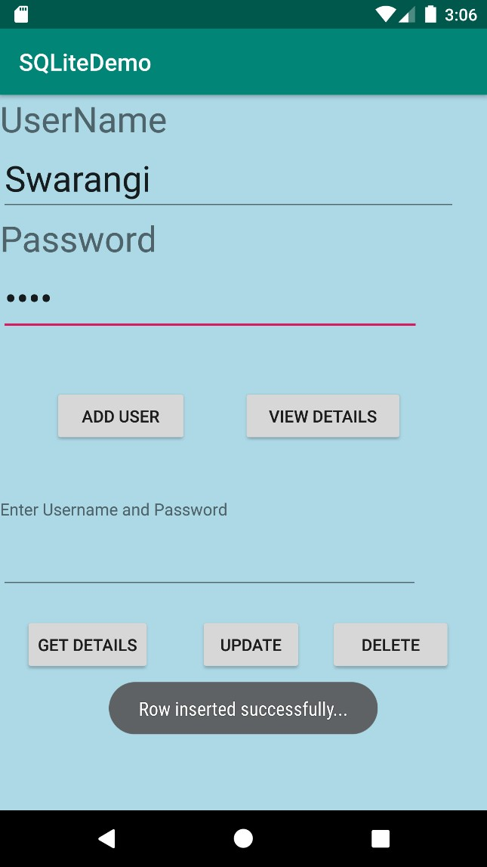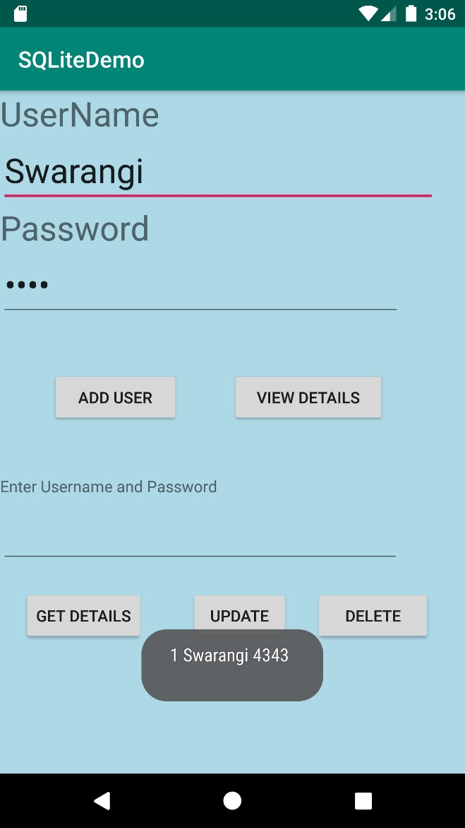

**Inserting rows**

**View Details**

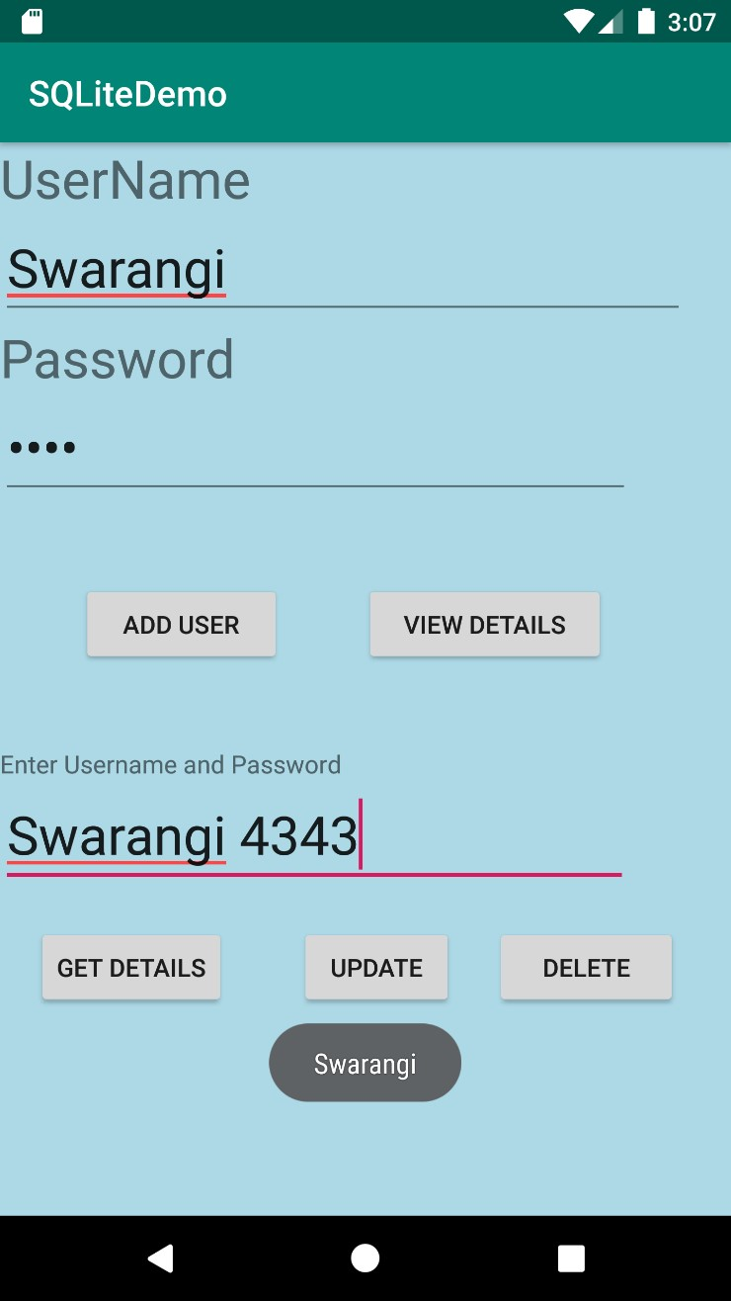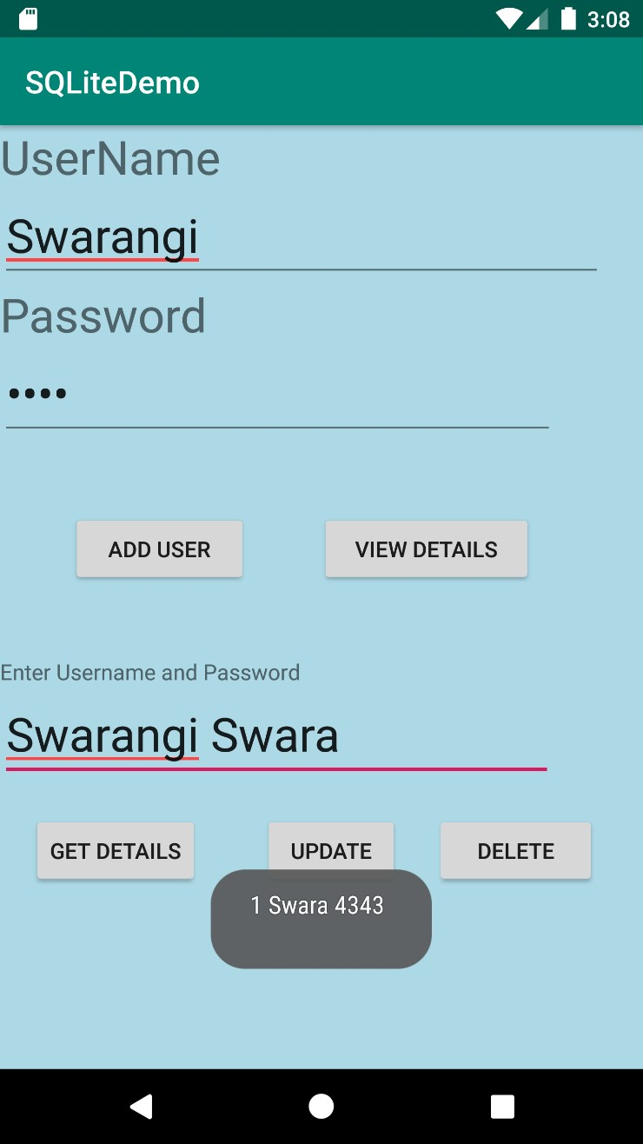

**Get Details Updating Data**

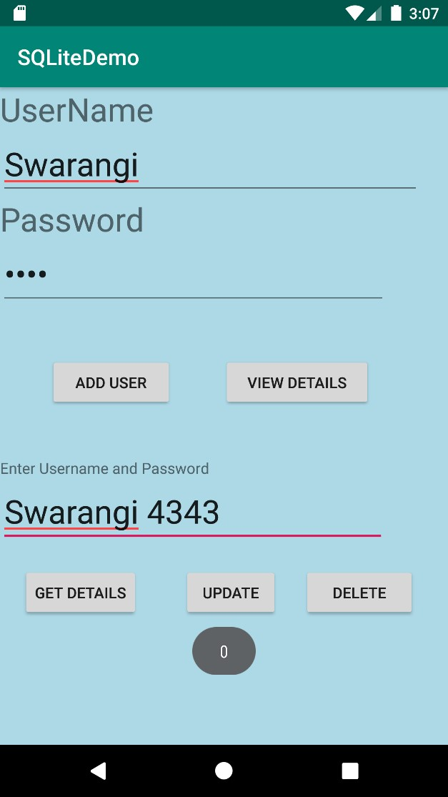**D**

**Deleting Data**